Practical-1 - 1
Practical Title: Project Initiation, Requirement Analysis, Sitemap, Wireframe, and GitHub Setup

Problem Definition: Initiate the semester-long StudentHub portal by identifying the problem scope, user roles, key modules, navigation flow, and minimum 10 pages. Create a sitemap, low-fidelity wireframe, project folder structure, README file, and GitHub repository.

Theory

What is URL and parts of URL?
Answer:
A URL (Uniform Resource Locator) is the address of a webpage on the internet. It helps the browser find and open a specific web page or file.
Parts of a URL:
- Protocol – https://
- Domain Name – www.example.com
- Path – /home.html

How does HTML file process in web browser?
Answer:
When an HTML file is opened, the browser reads the HTML code and creates the page structure. It then loads CSS for styling and JavaScript for interactivity. Finally, the browser displays the webpage on the screen.

3. How will page navigation flow managed among all HTML pages?
Answer:
Page navigation will be managed using HTML <a> links. A common navigation bar will be added to every page so users can easily move between pages like Home, Login, Dashboard, Profile, and Contact. Relative paths will be used to link the HTML files.

4. How will GitHub commits be maintained after each practical?
Answer: After every practical, I will save my changes, commit them with a meaningful message, and push them to GitHub. Each commit will describe the work completed, making it easy to track project progress.

Implementation/ Output/Result
- Created the StudentHub Portal project.
- Identified the project scope, user roles, and key modules.
- Designed a sitemap for website navigation.
- Prepared 10-page low-fidelity wireframes.
- Created the project folder structure.
- Added a README.md file.
- Created a GitHub repository and uploaded the project.

Evidence of Work (Screenshots)
About
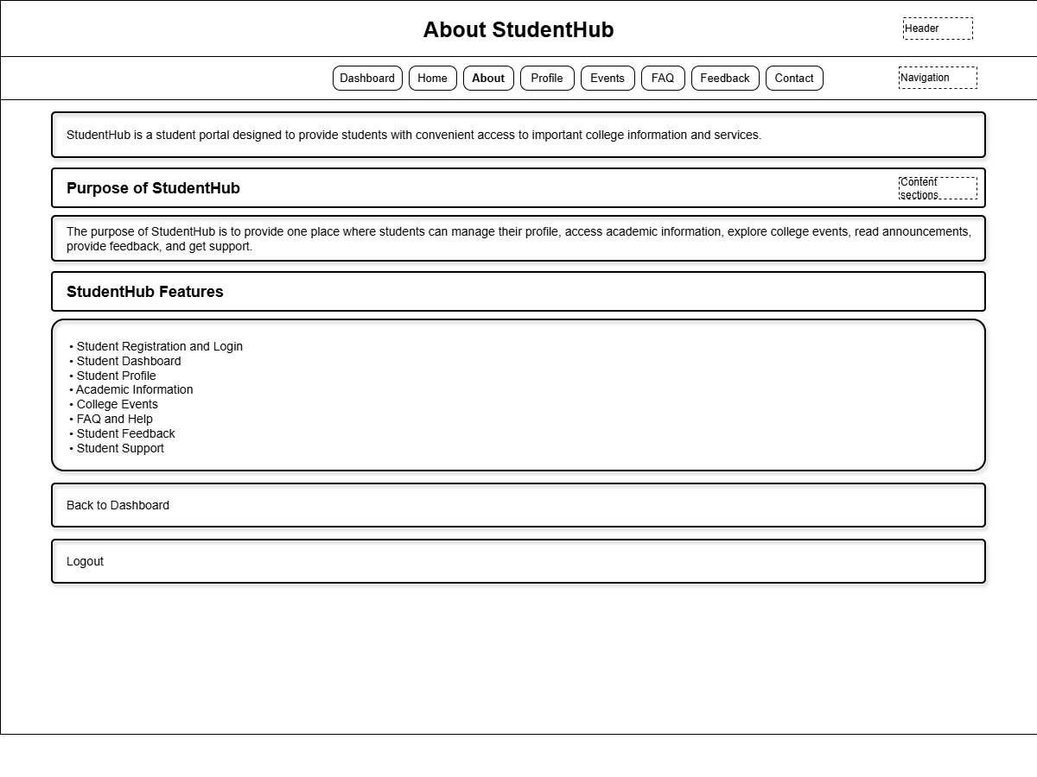

Contact
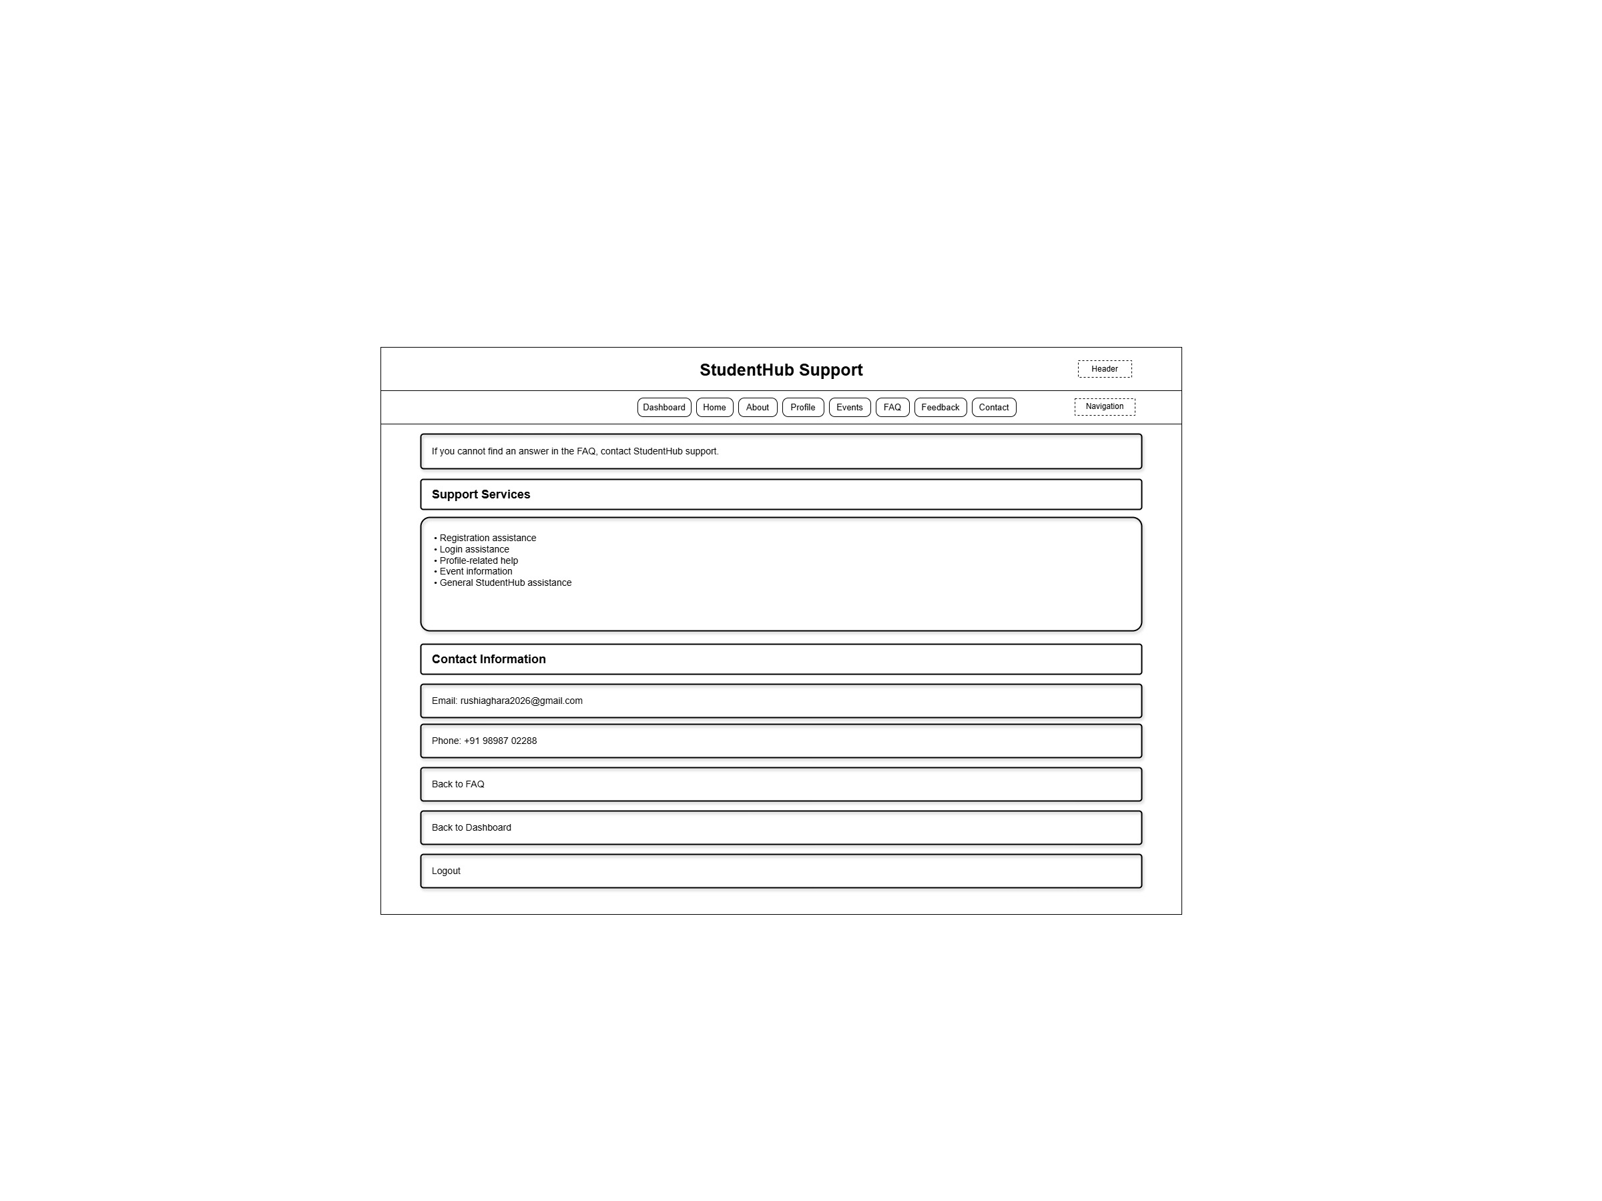

Dashboard
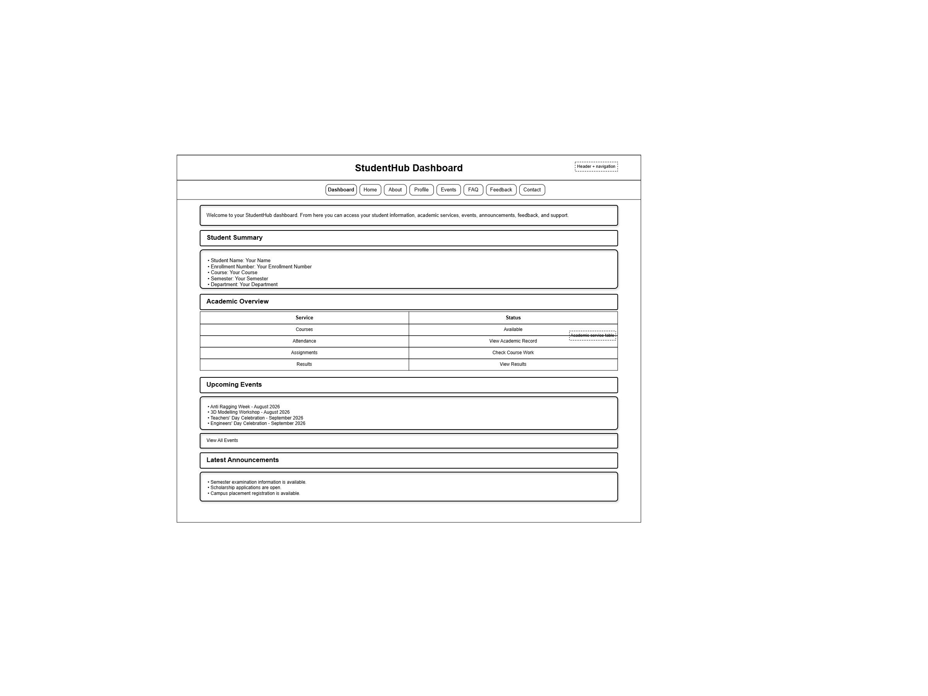

Event
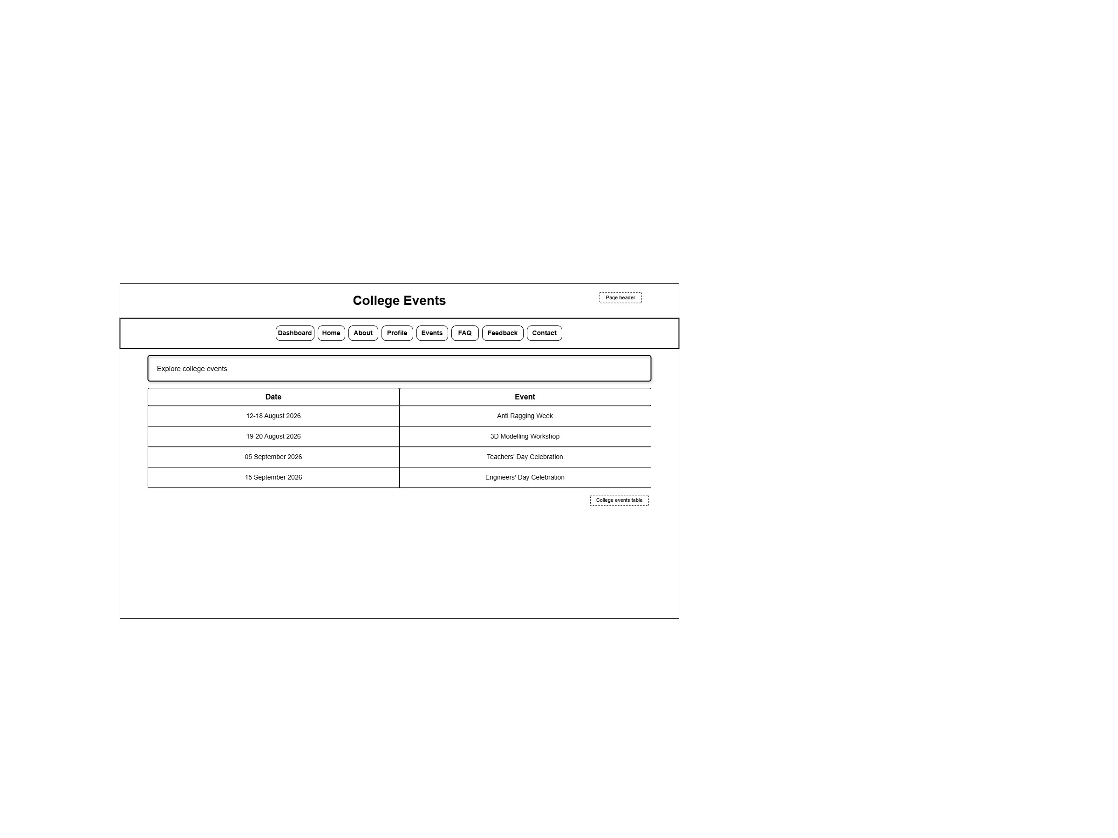

Faq
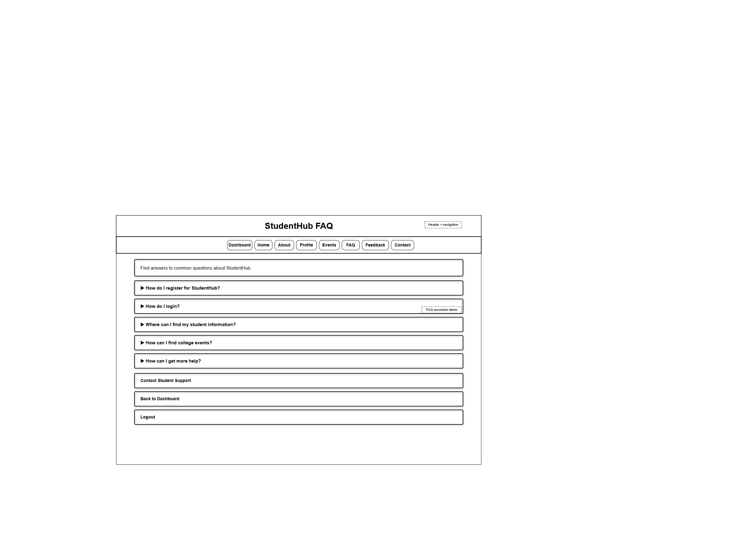

Feedback
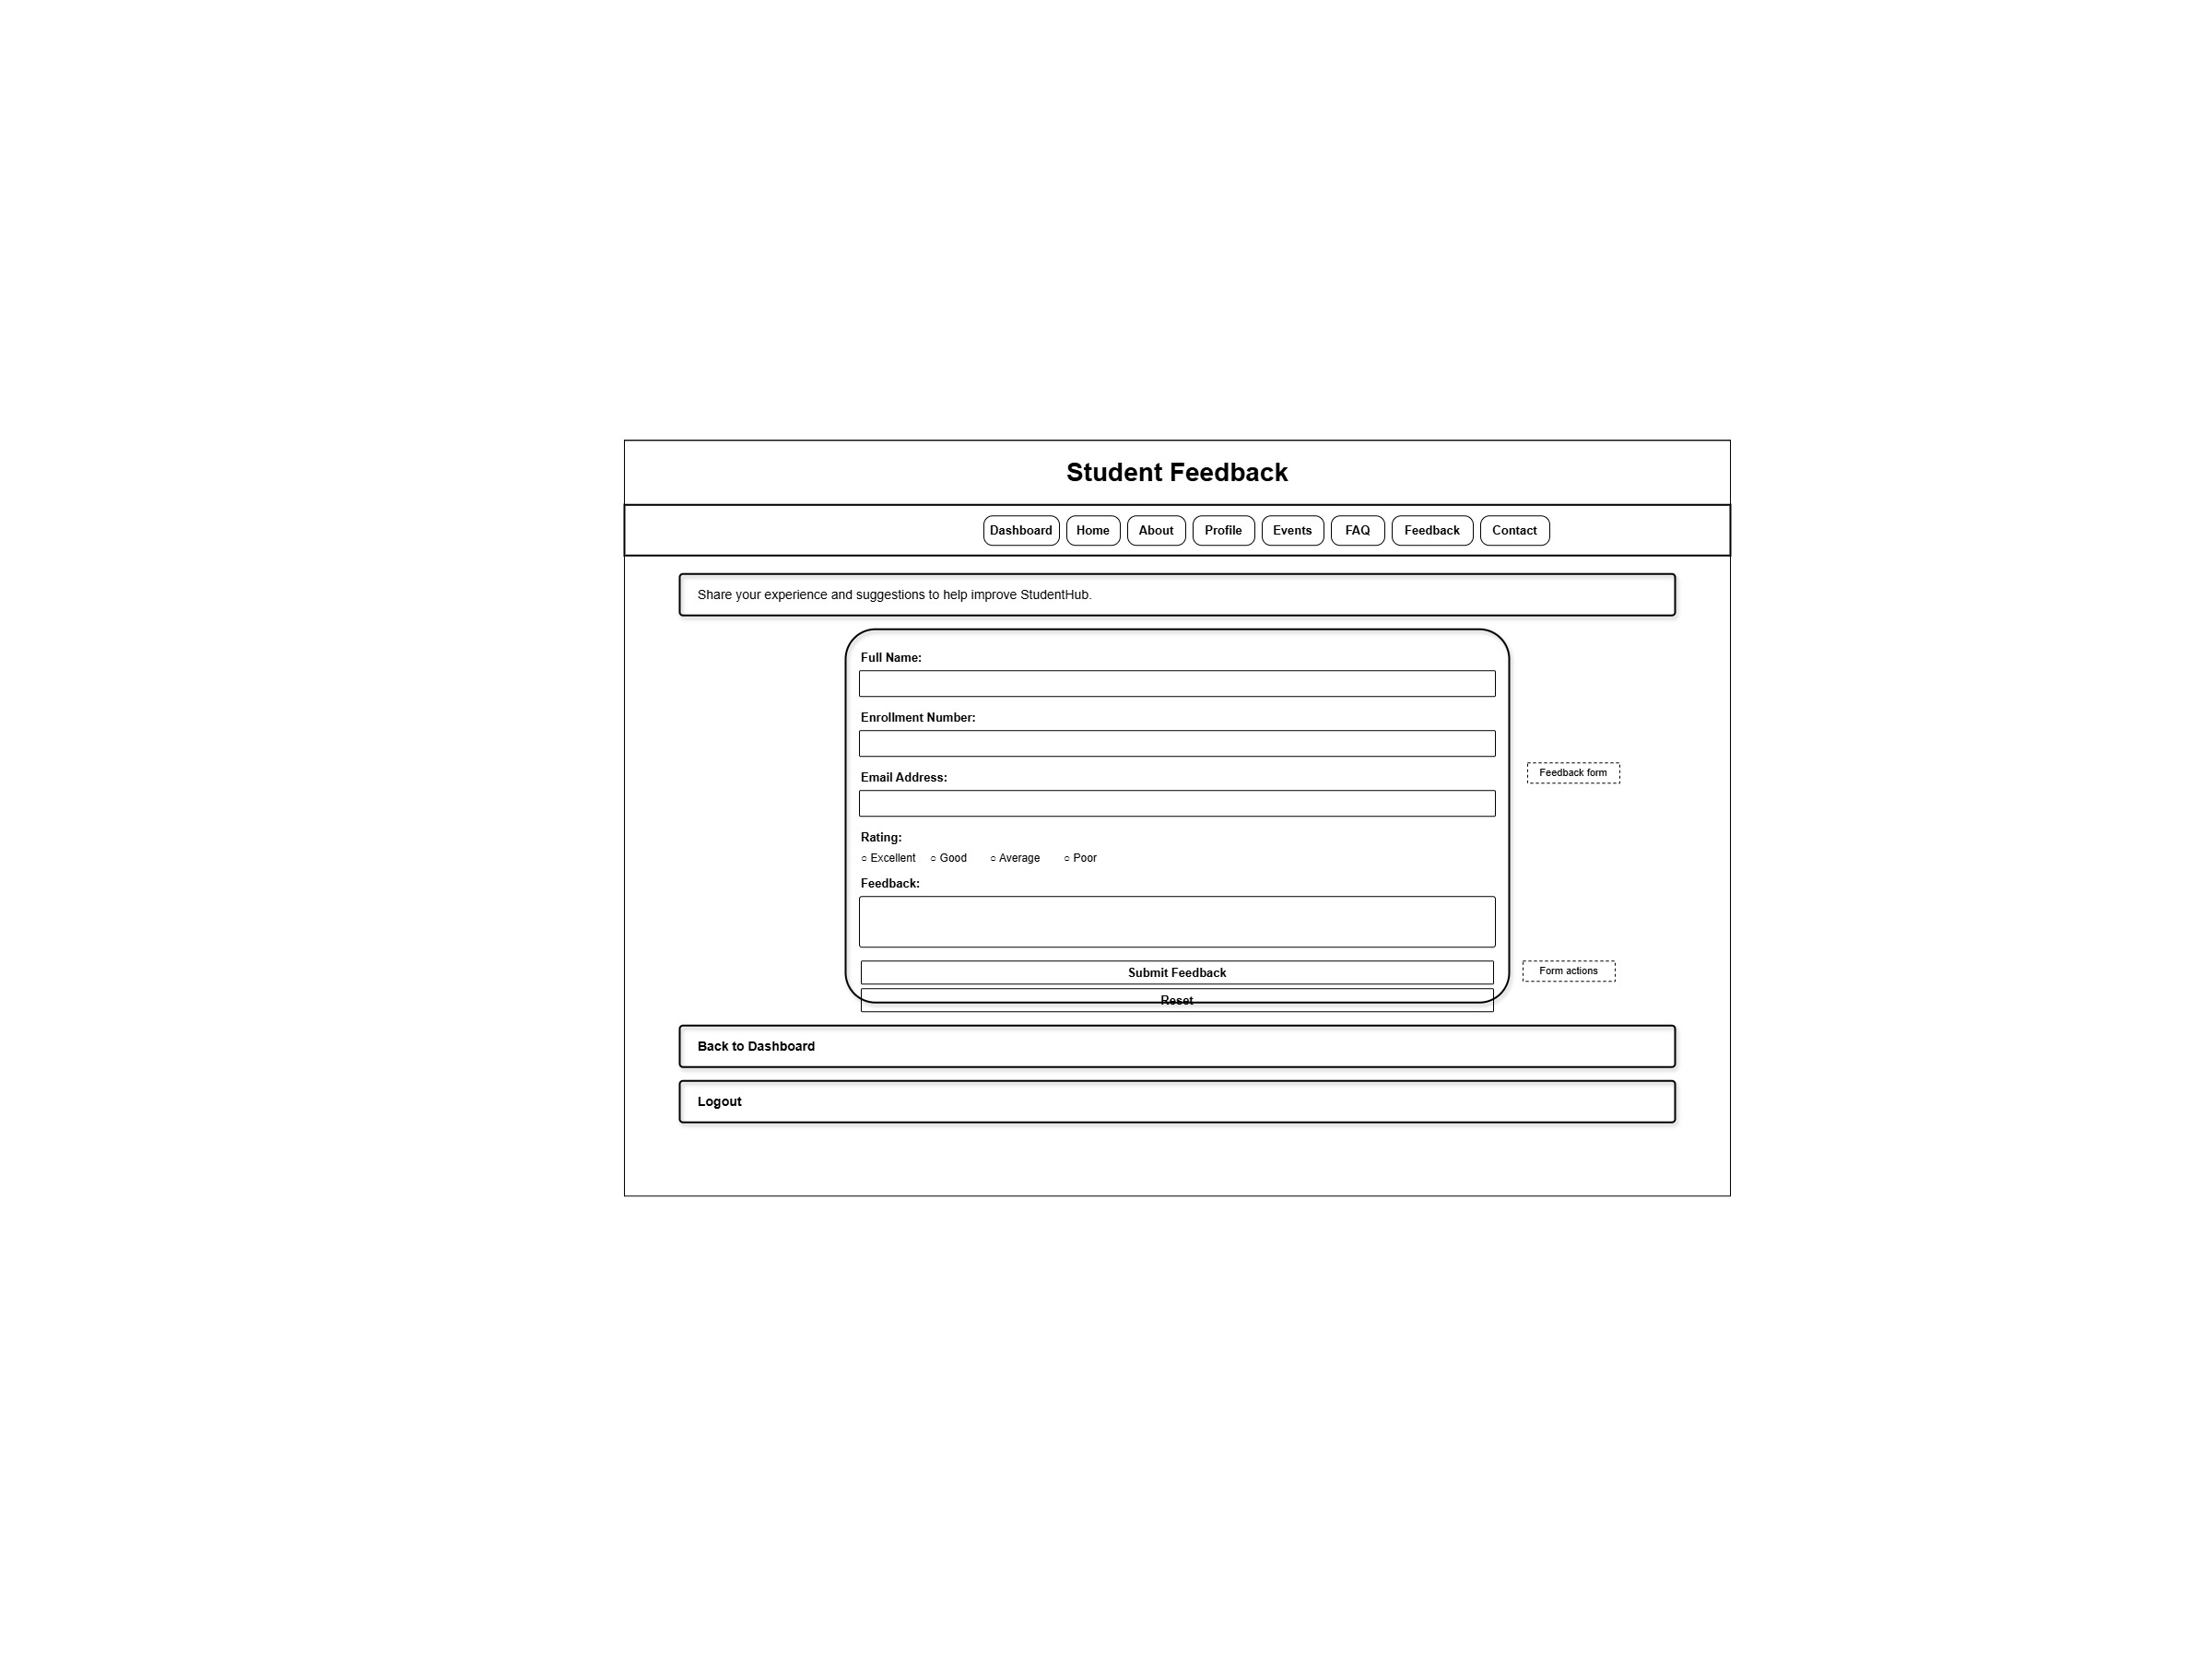

Home
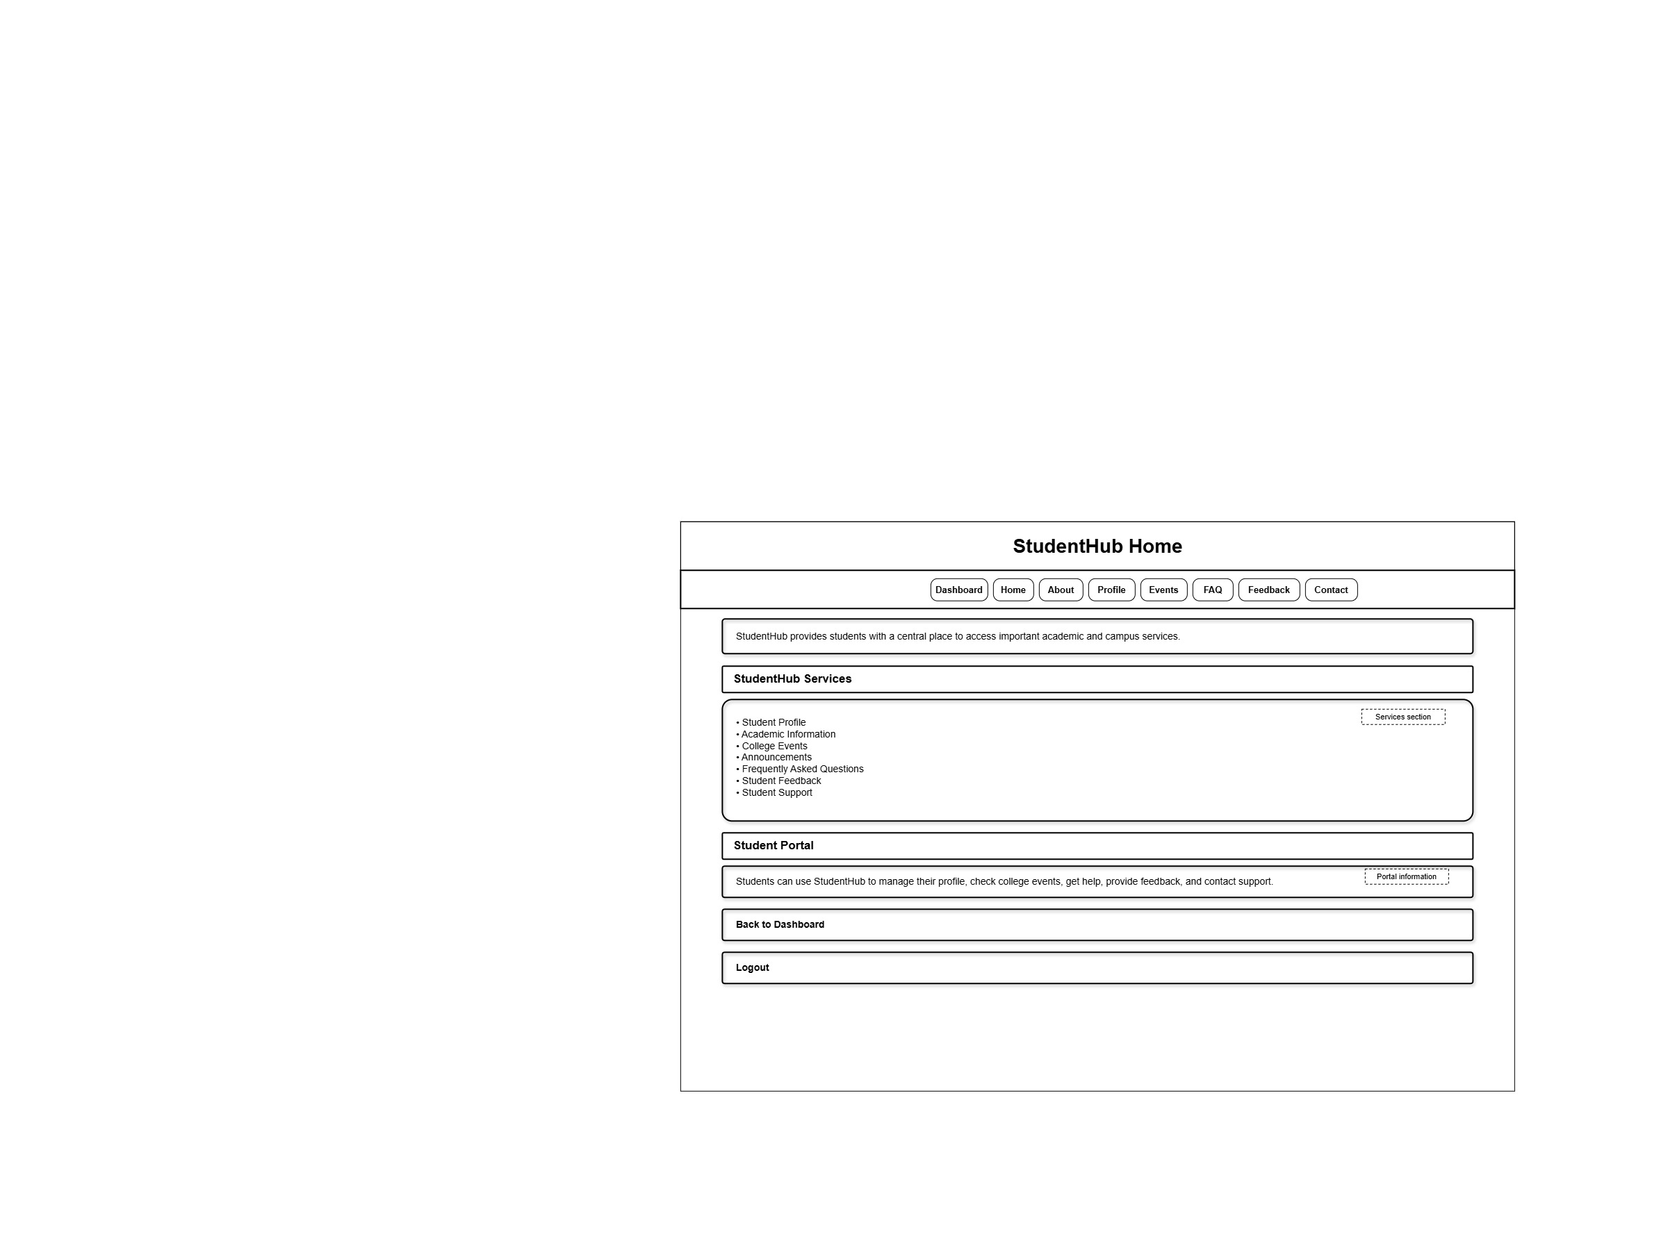

Index
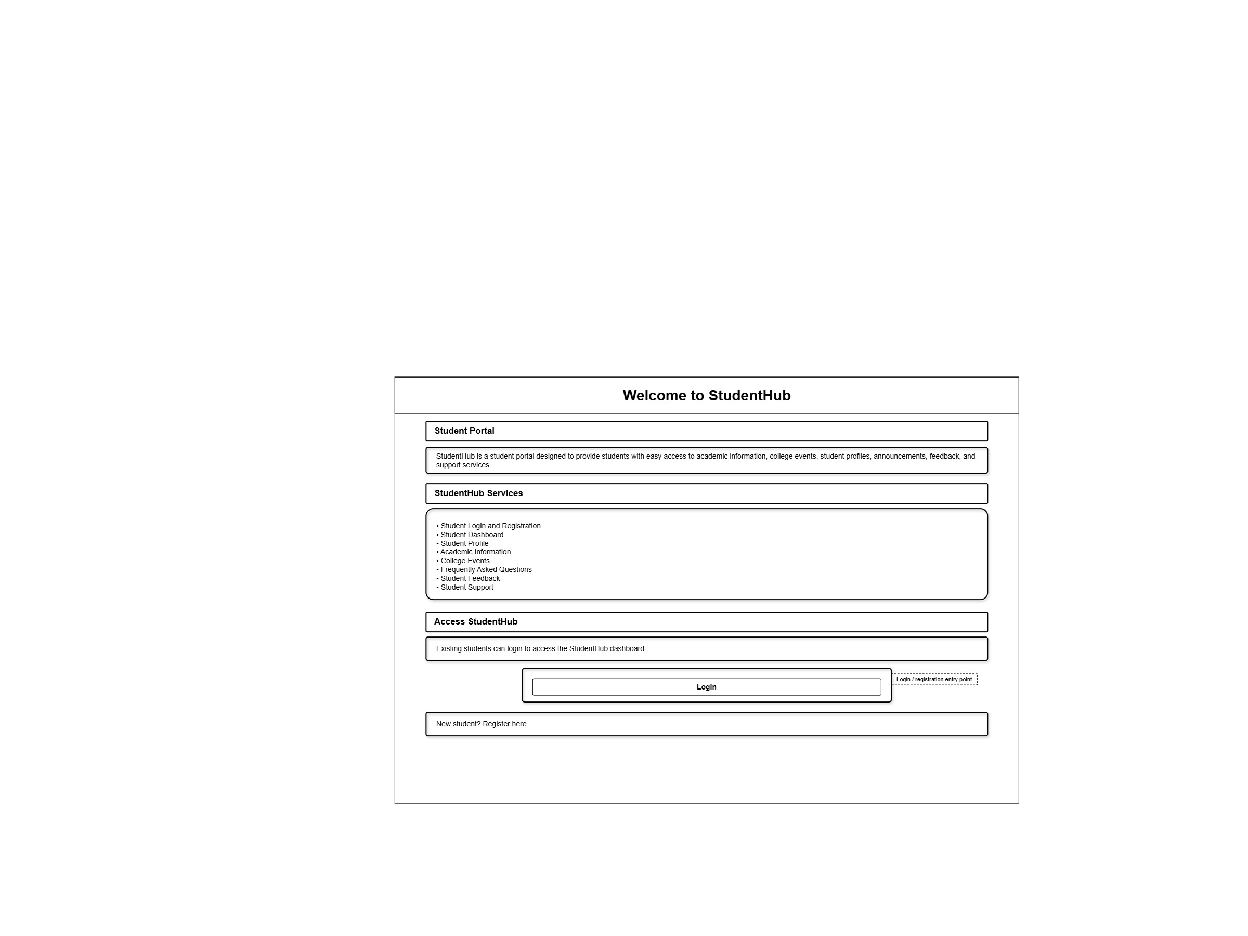

Login
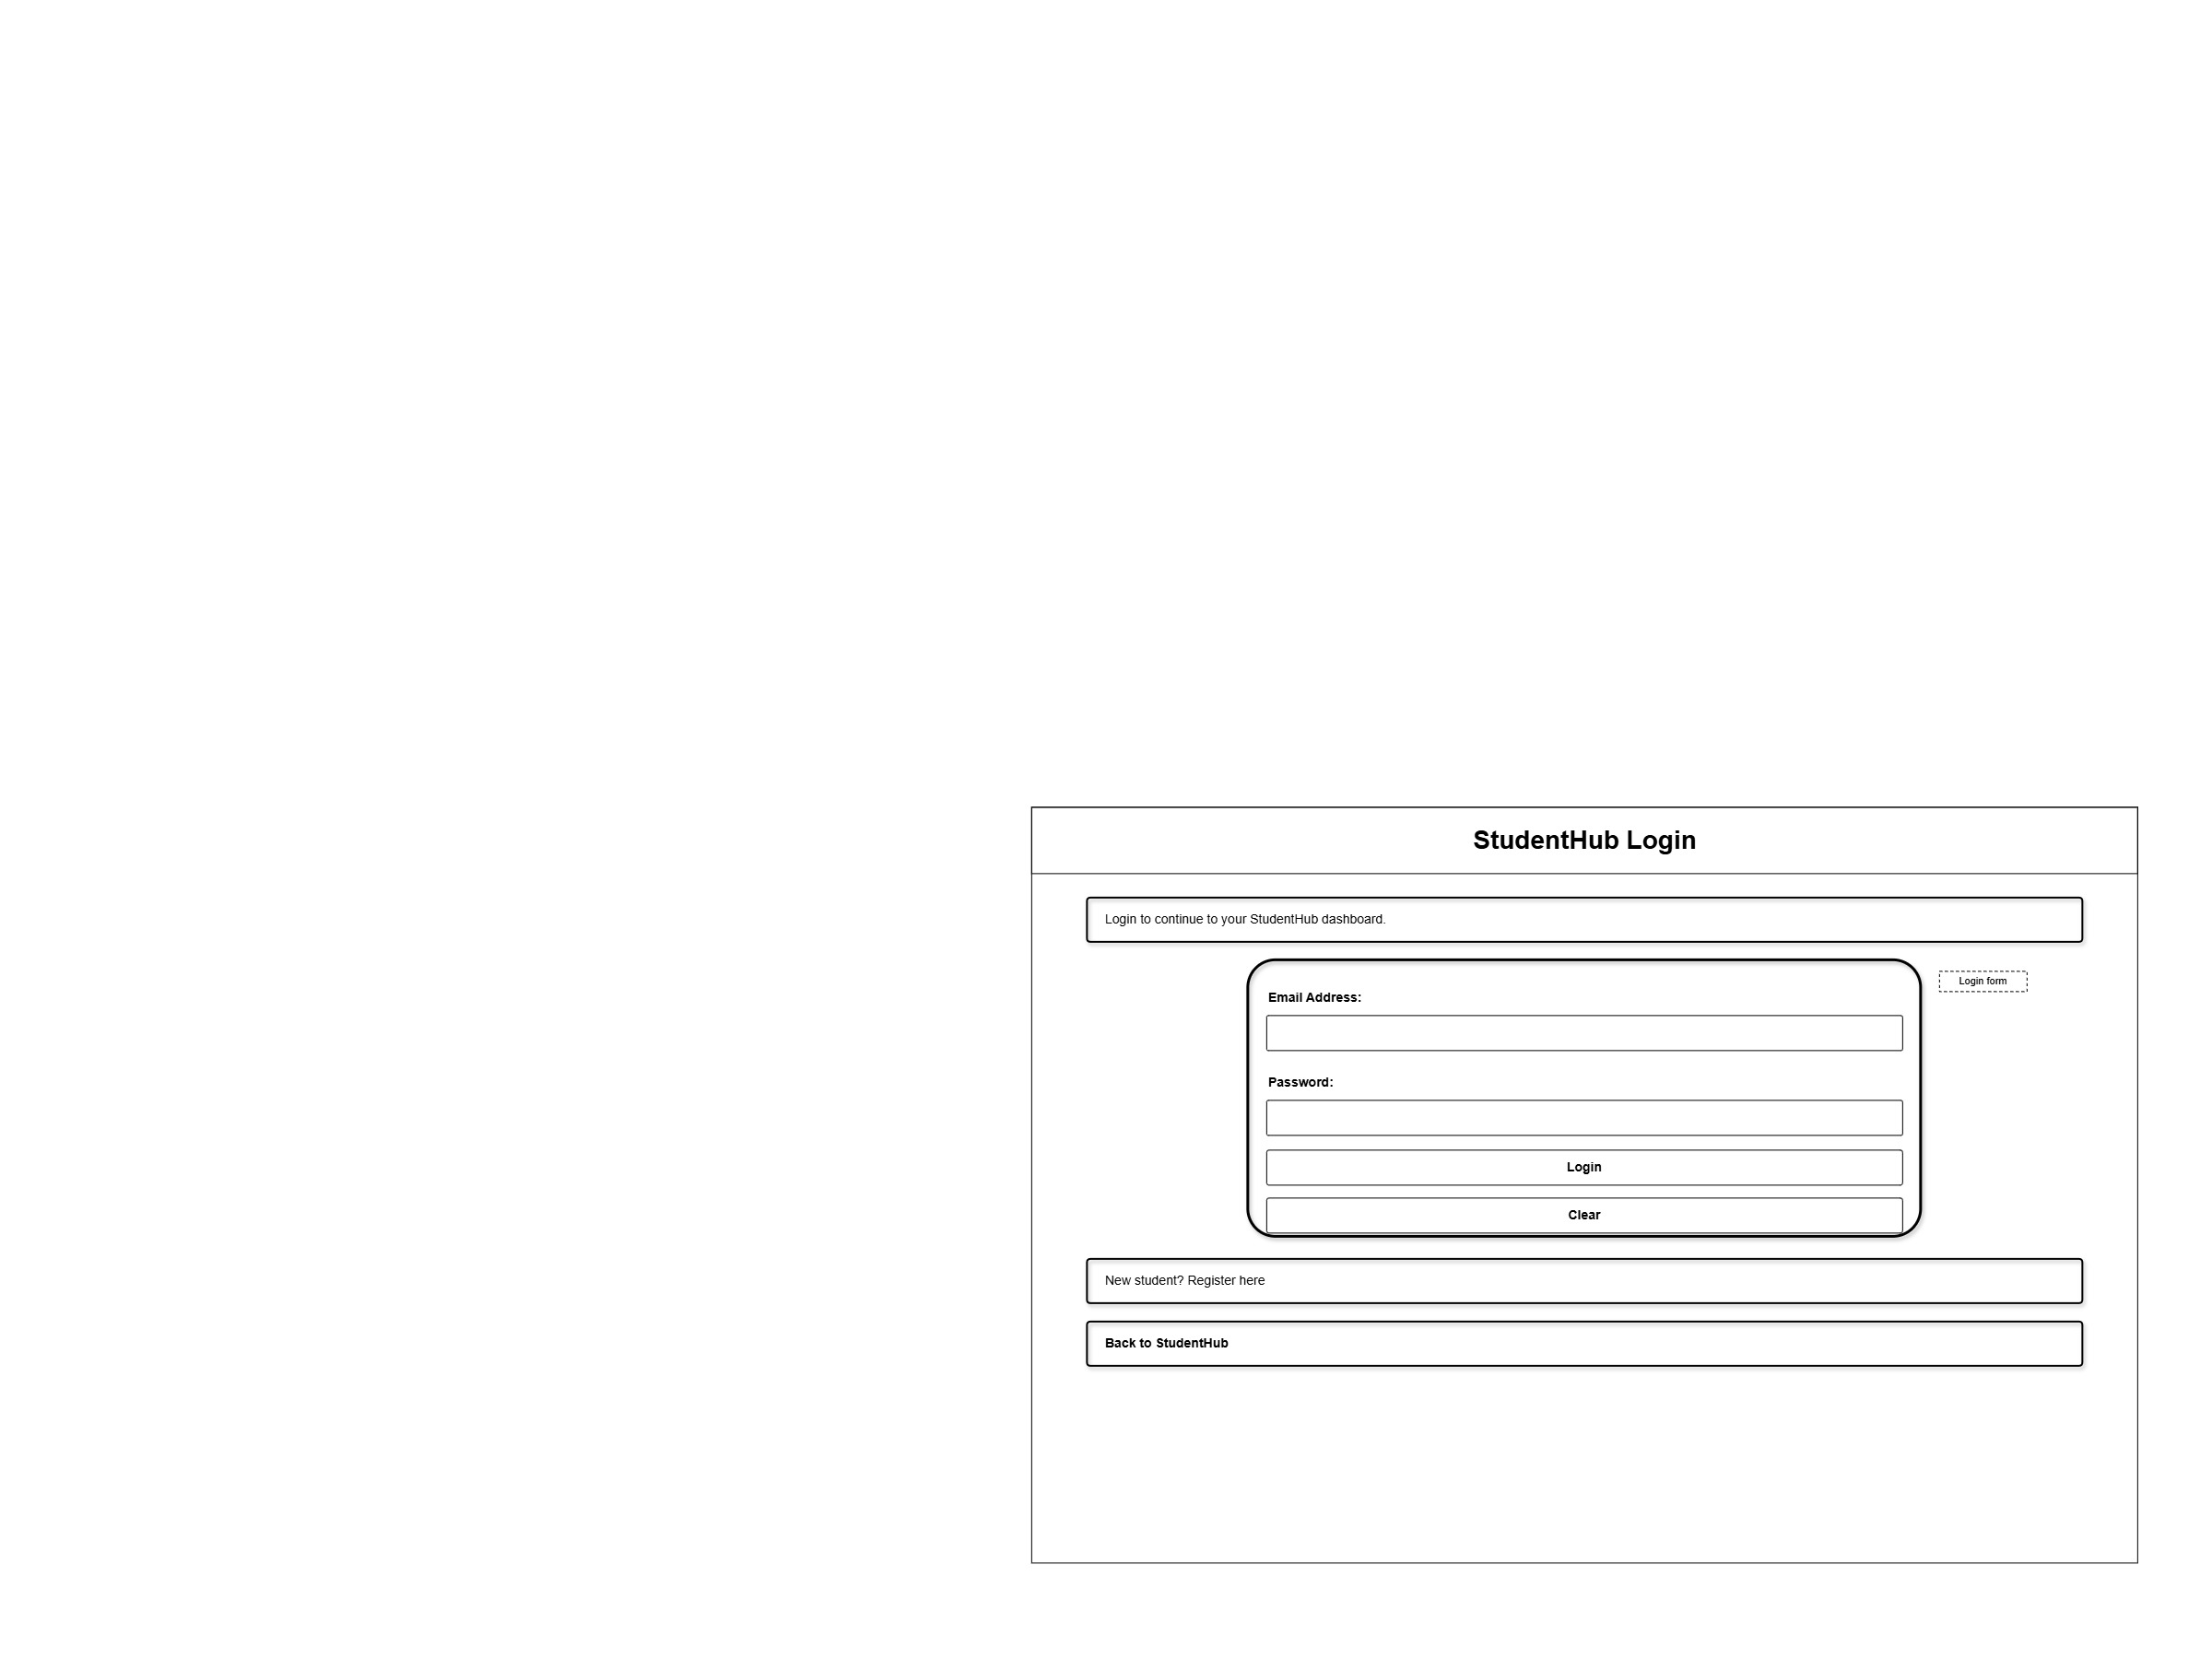

Profile
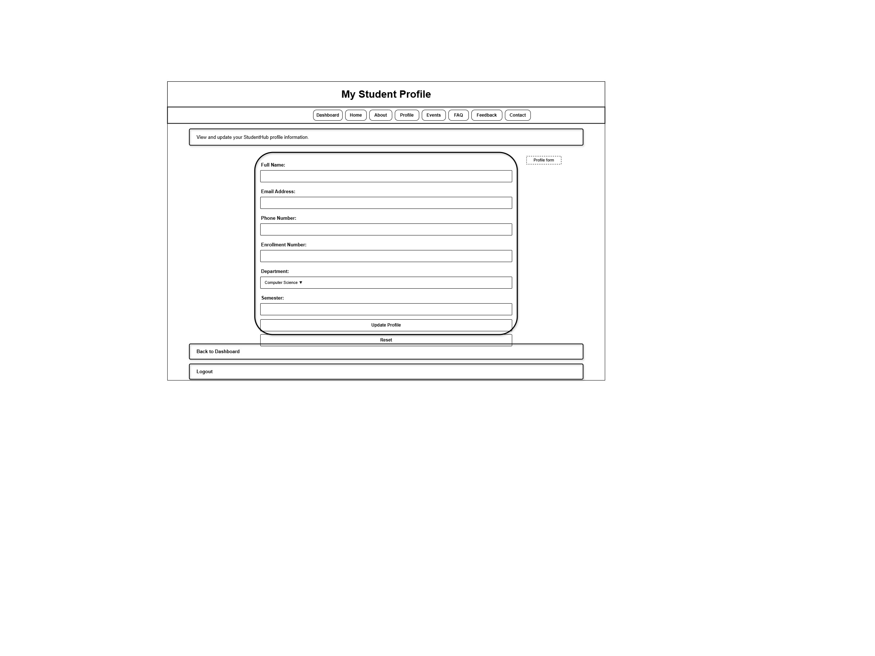

Registration
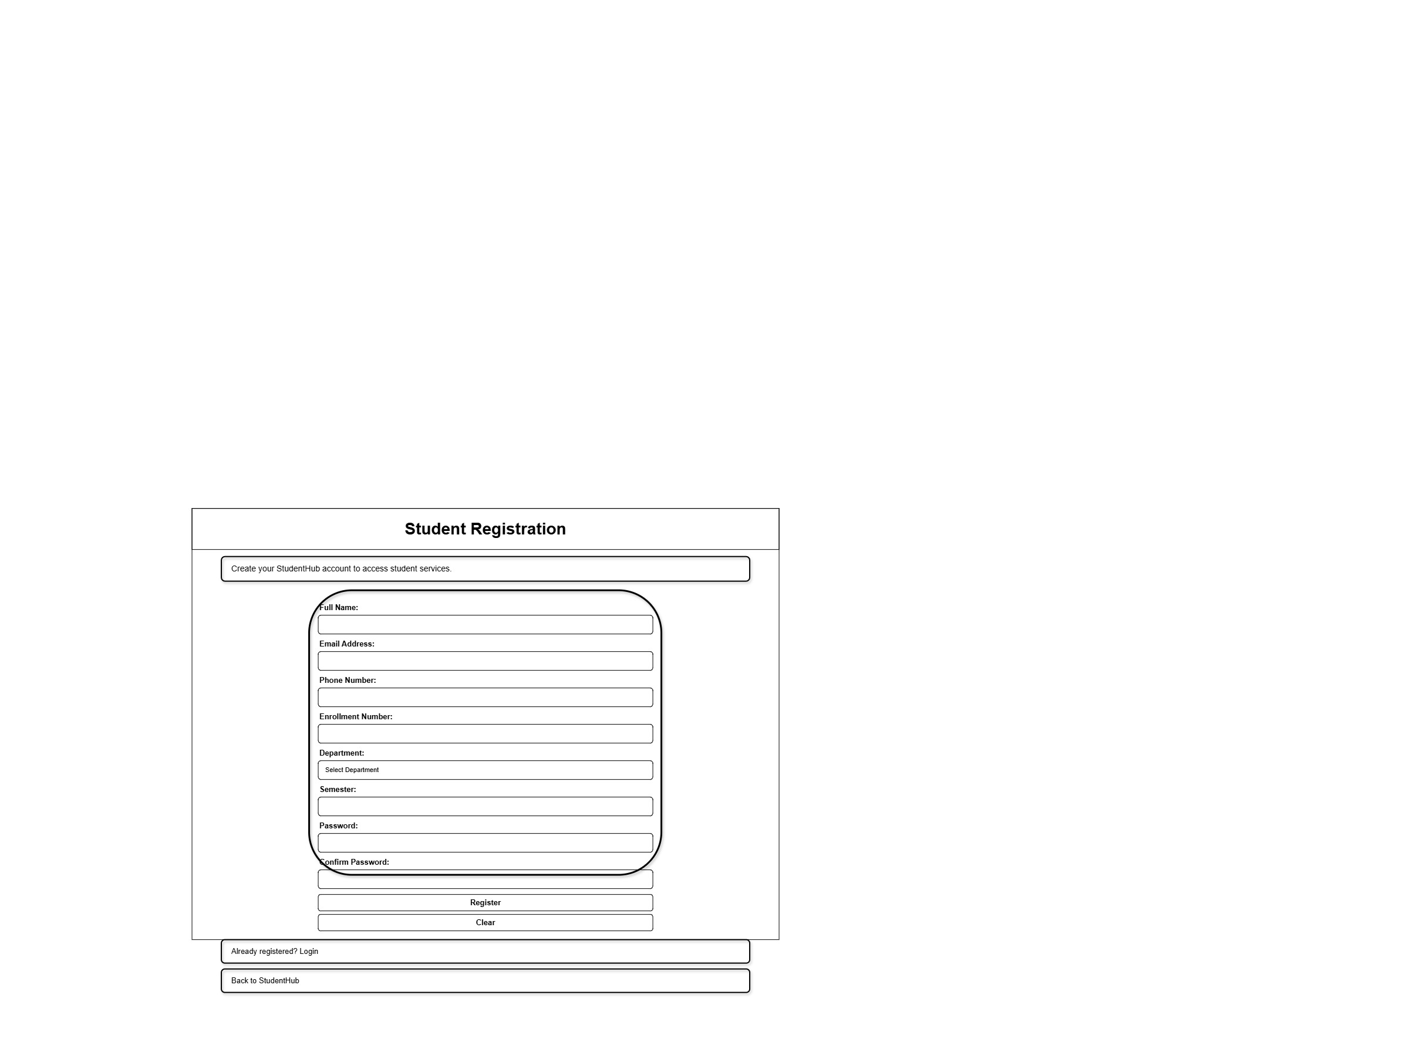

GitHub Repository Link:
https://github.com/rushiaghara25/StudentHub-Portal-2.git

Challenges Faced:
- Understanding how to organize multiple HTML pages.
- Creating a proper sitemap and navigation flow.
- Setting up the GitHub repository and uploading the project files.

Learning Outcomes:
- Learned how to plan a website before development.
- Understood project structure and page navigation.
- Learned to create wireframes and a sitemap.
- Learned to use GitHub for version control and project management.

Faculty Remarks: (Keep this blank for faculty)

Practical - 2
Practical Title: Semantic HTML5 Pages with Accessibility-Ready Structure

Problem Definition: Develop static HTML5 skeletons for at least 10 StudentHub pages such as Home, About, Register, Login, Dashboard, Events, Profile, Contact, Admin, FAQ, and Feedback. Use semantic tags and accessibility-friendly

structure.

Theory

Are semantic tags such as header, nav, main, section, article, aside, and
footer used properly?
Answer: Yes, semantic tags like <header>, <nav>, <main>, <section>, and <footer> are used to organize the webpage and improve readability.

Are form labels, headings, image alt text, and navigation links
accessible?
Answer: Yes, forms use proper labels, headings follow a clear hierarchy, images include alt text, and navigation links are easy to access.

Is the page structure consistent across all pages?
Answer: Yes, all pages follow the same layout with a common header, navigation bar, main content area, and footer, providing a consistent user experience.

Implementation/ Output/Result
FAQ
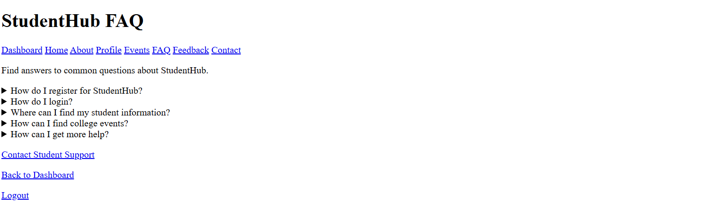
about
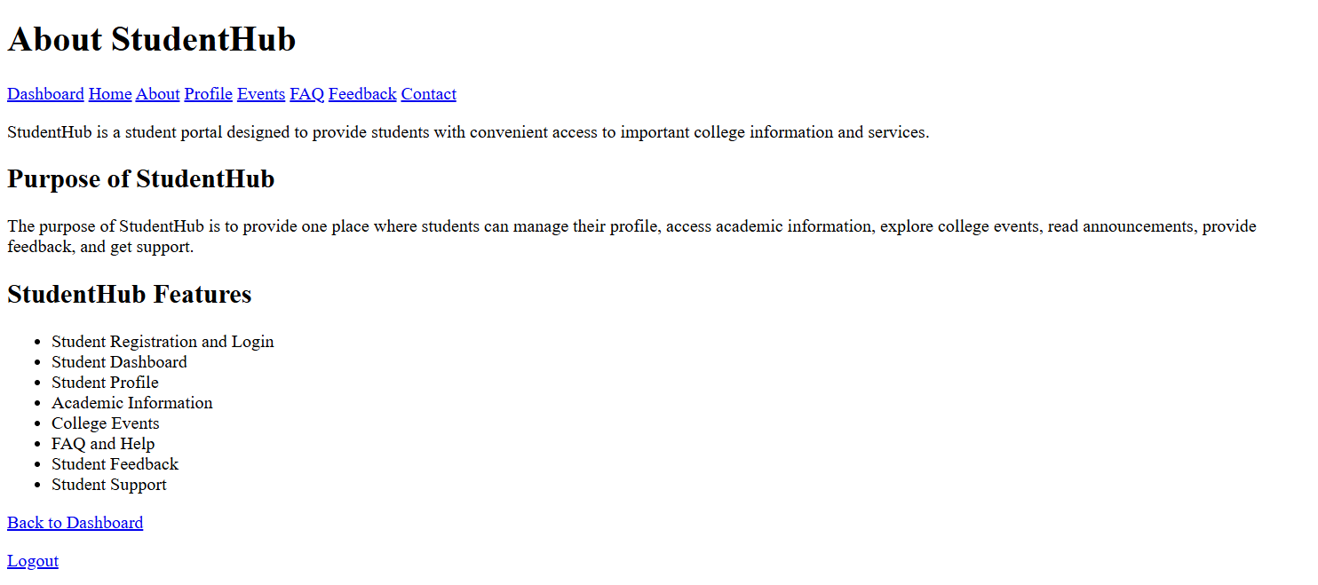contact


dashboard
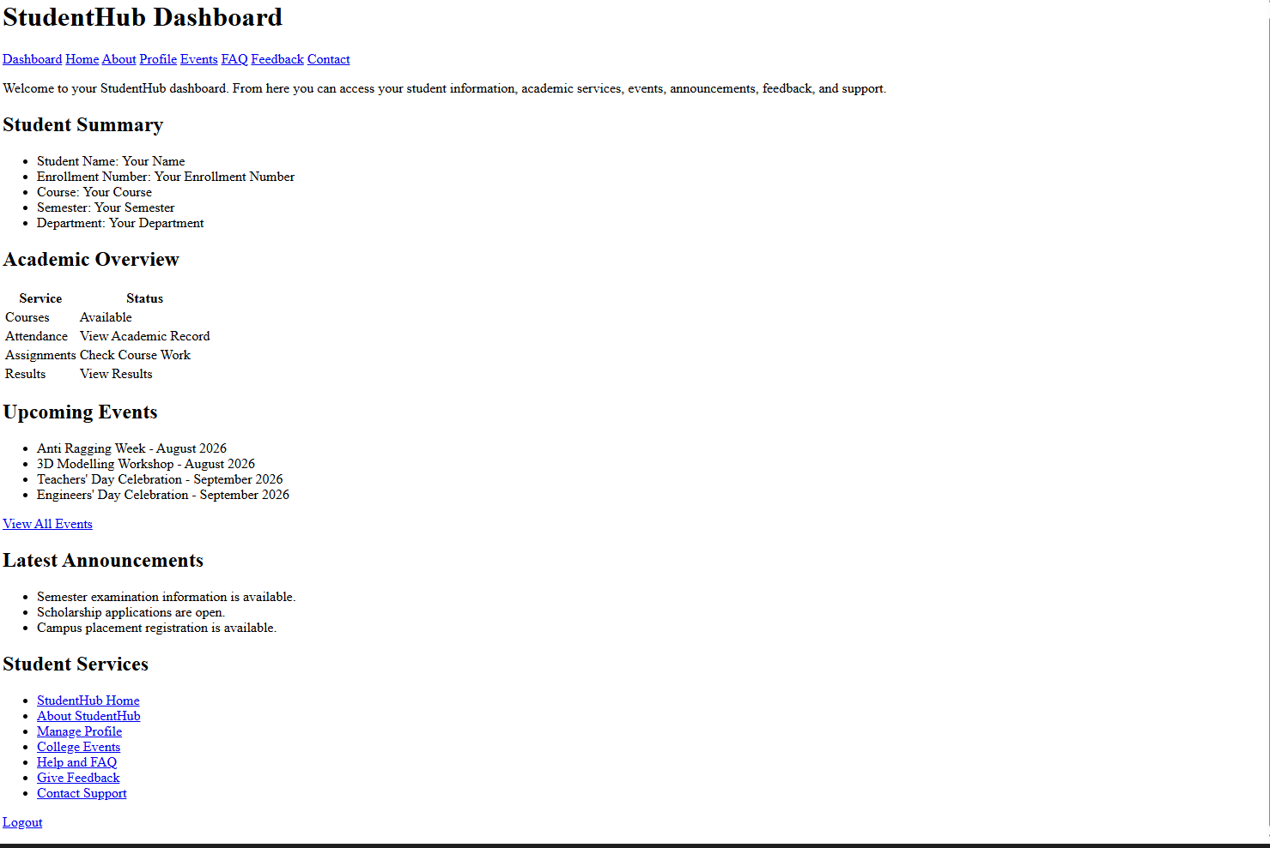
event

Feedback
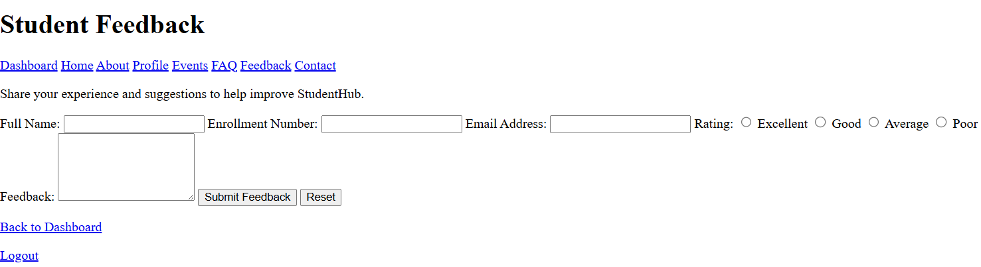
home
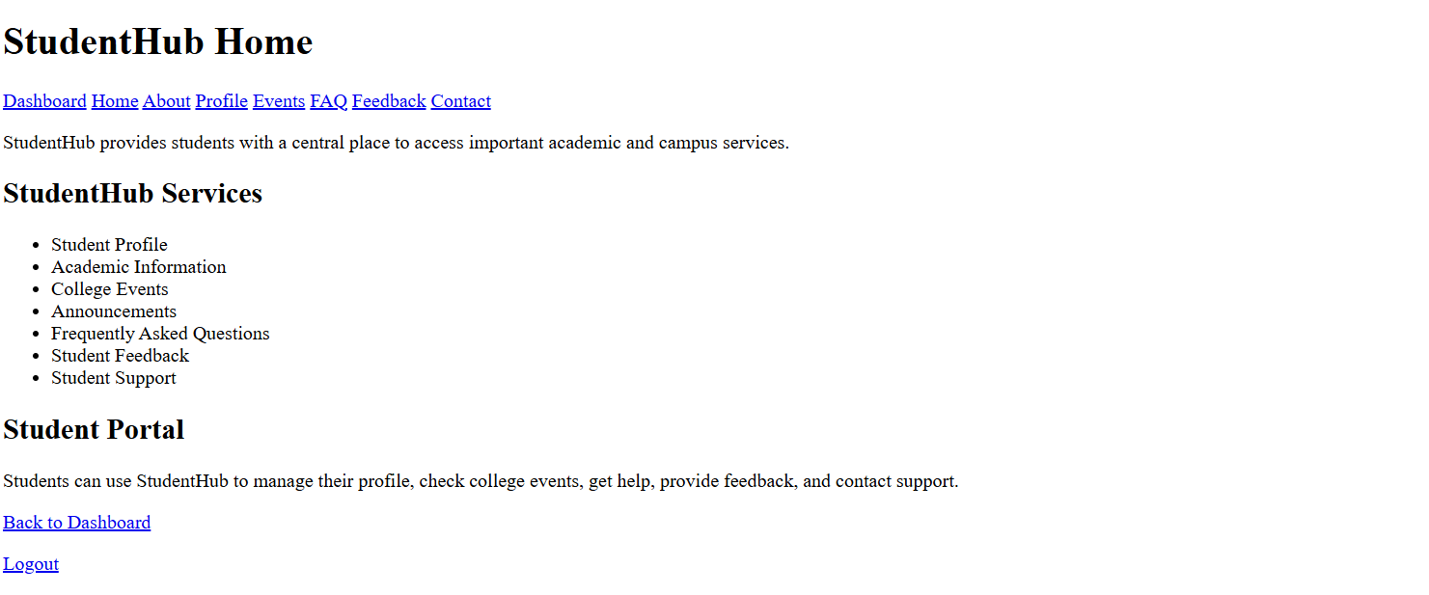
index
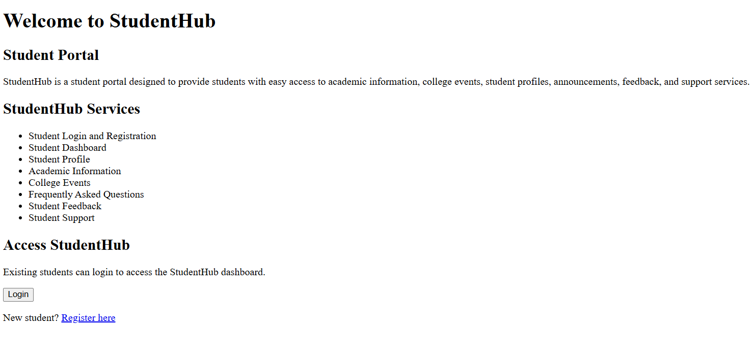
login
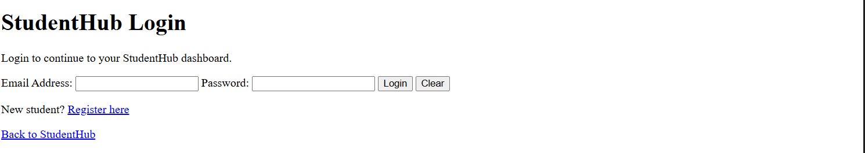

profile
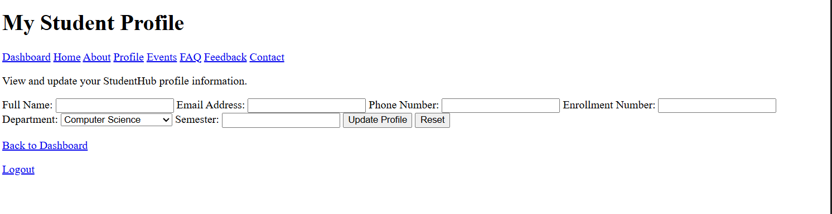
registration
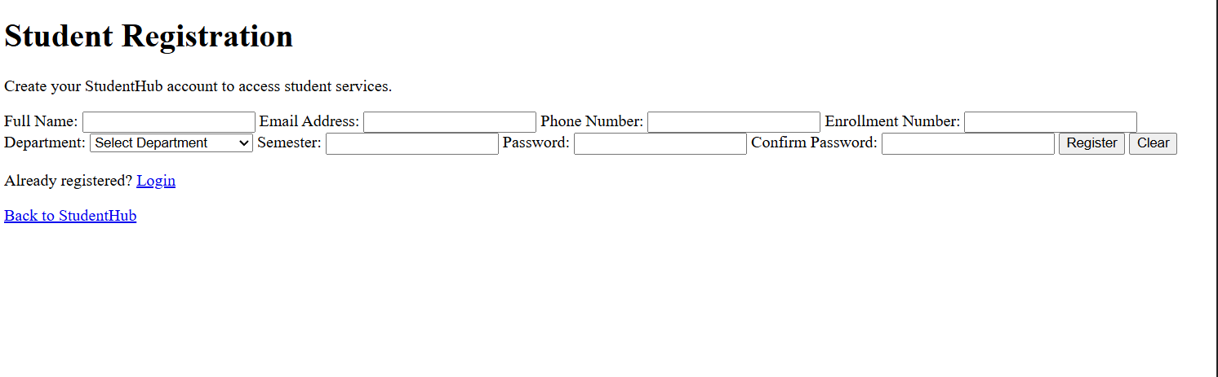

GitHub Repository Link:

https://github.com/rushiaghara25/StudentHub-Portal-2.git

Challenges Faced:
Used semantic HTML tags correctly.
Fixed navigation and page structure issues.

Learning Outcomes:
Learned semantic HTML5.
Improved webpage structure and accessibility.
Created consistent layouts for multiple pages.

Faculty Remarks: (Keep this blank for faculty)

Practical - 3
Practical Title: Responsive UI Design using CSS Grid, Flexbox, and Bootstrap/Tailwind
Problem Definition: Design responsive layouts for Home, About, Registration, Dashboard, and Events pages using CSS Grid and Flexbox. Optional to use CSS framework such as Bootstrap or Tailwind. Ensure mobile-first responsiveness.
Theory :
1. How does the layout adapt for mobile, tablet, and desktop screens?
The website uses a responsive design that adjusts automatically to different screen sizes. Mobile devices display a single-column layout, tablets use two columns, and desktops use multiple columns. Images and forms resize according to the screen. This provides a better user experience on all devices.
2. Which layout technique is used and why?
CSS Flexbox is used for navigation bars, buttons, and forms because it aligns items easily in one direction. CSS Grid is used for page layouts and dashboard sections because it handles rows and columns efficiently. Together, they create a flexible and responsive design.
3. Are typography, spacing, colours, and contrast readable?
Yes, the website uses readable font sizes, proper spacing, and consistent colors. Good contrast between text and background improves visibility. Headings are larger than body text, making the content easy to read on all devices.
4. Is the framework used consistently without unnecessary inline CSS?
Yes, Bootstrap/Tailwind classes and external CSS are used consistently throughout the website. Inline CSS is avoided to keep the code clean and maintainable. This ensures a uniform design across all pages.

Implementation/ Output/Result

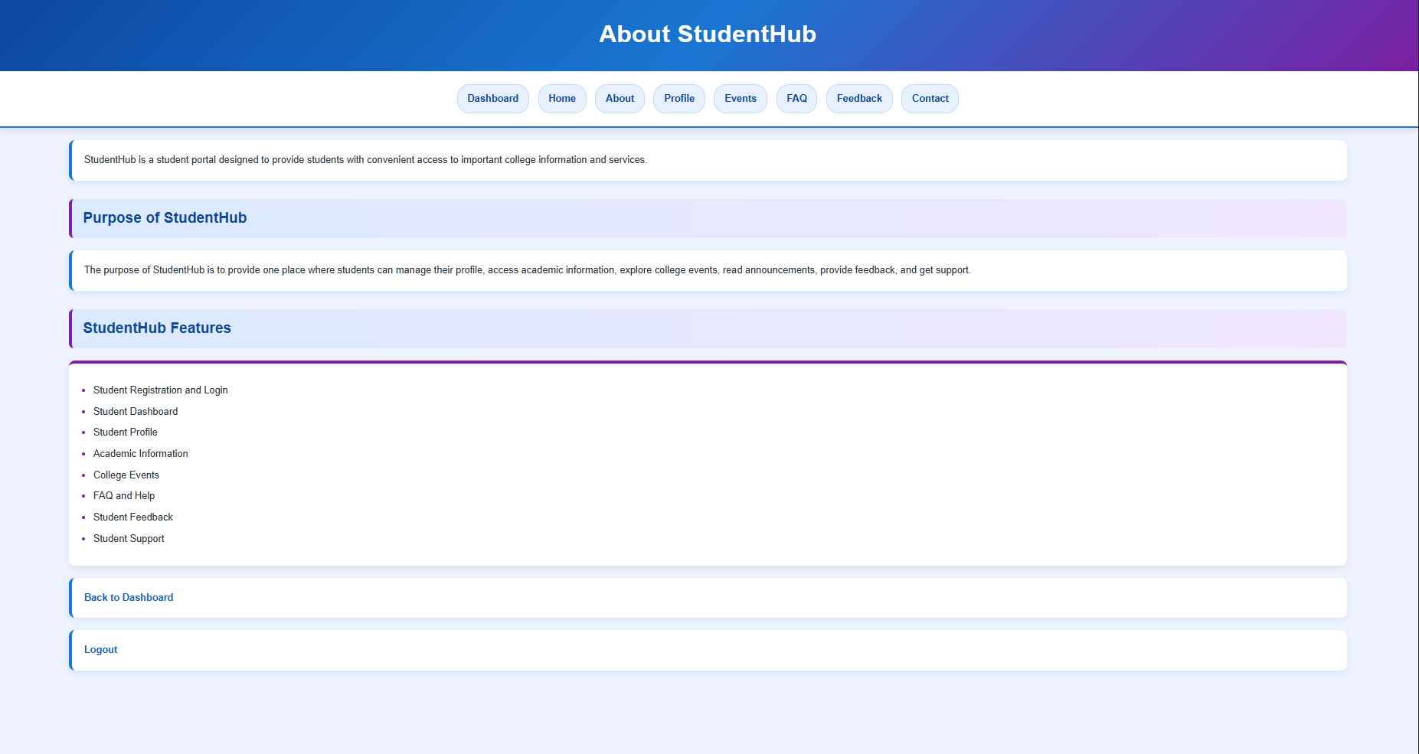

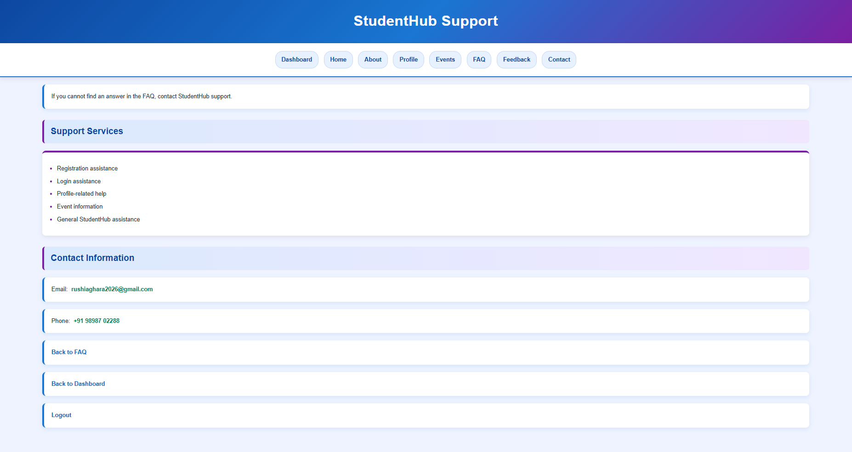
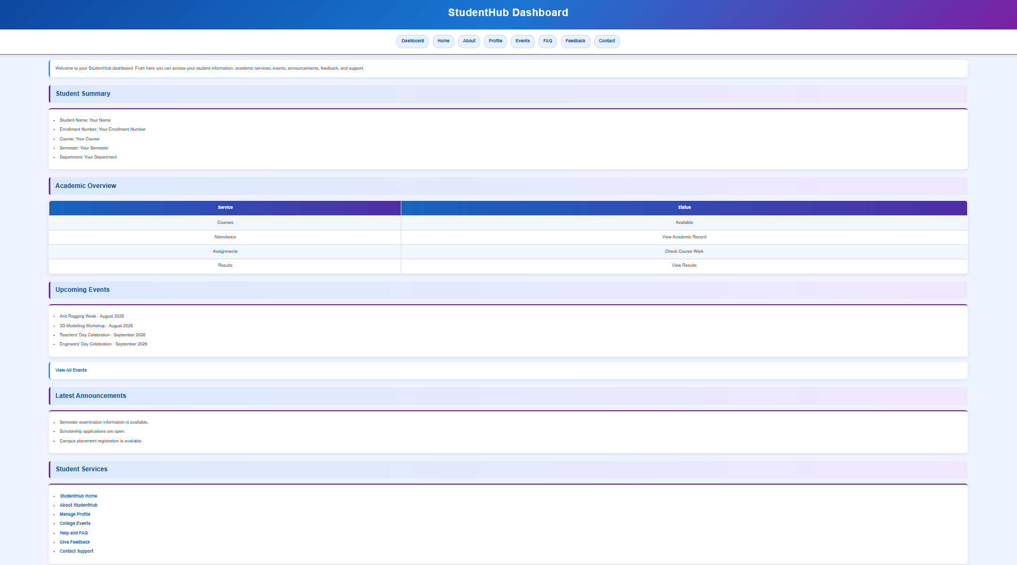

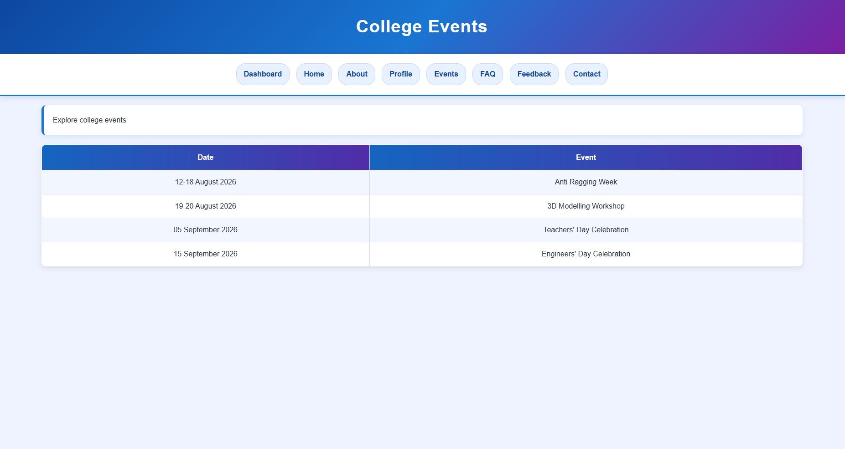

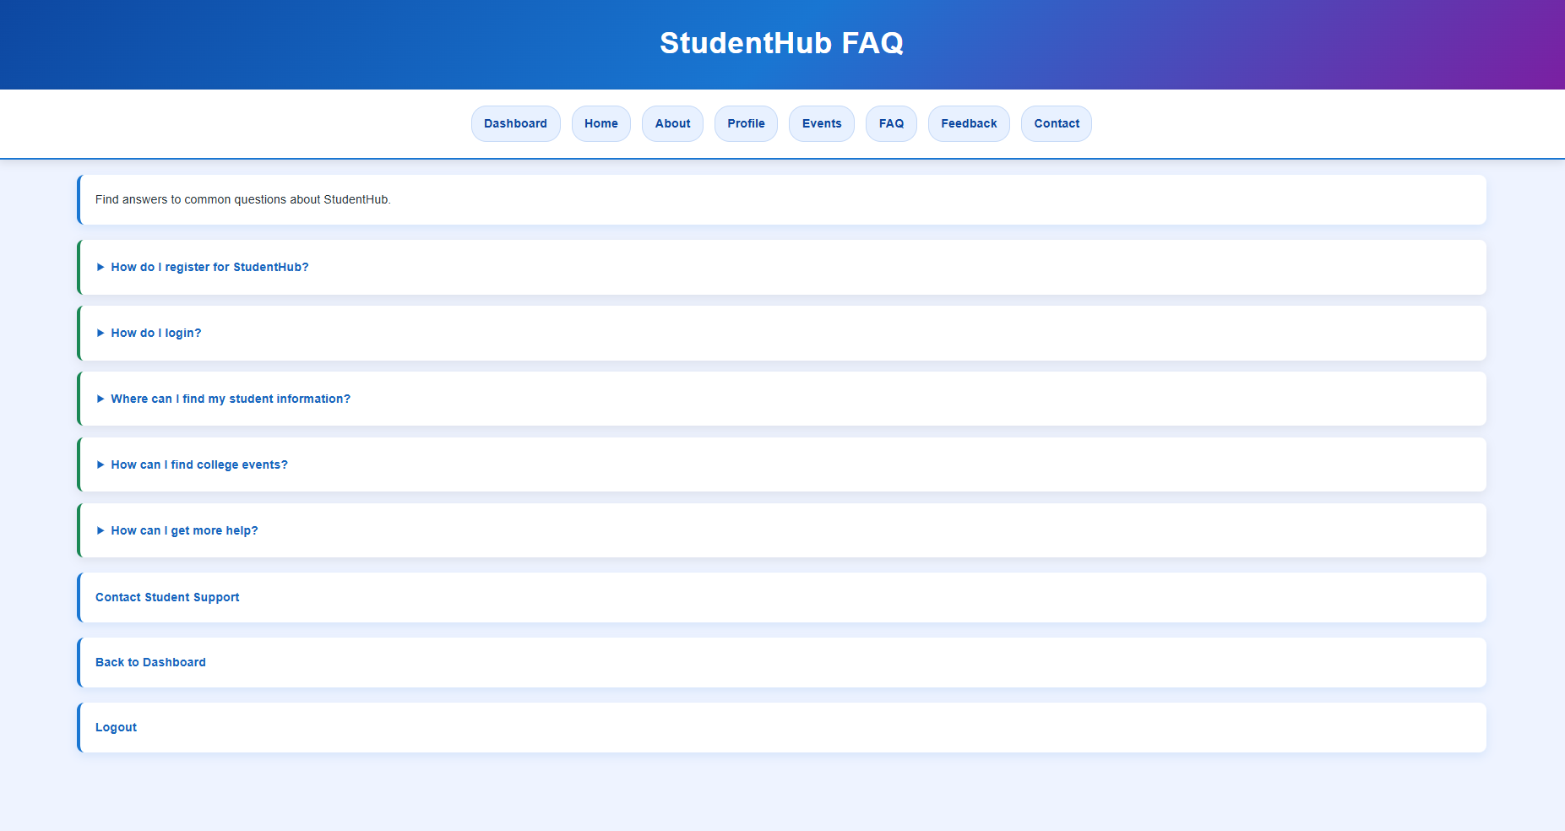

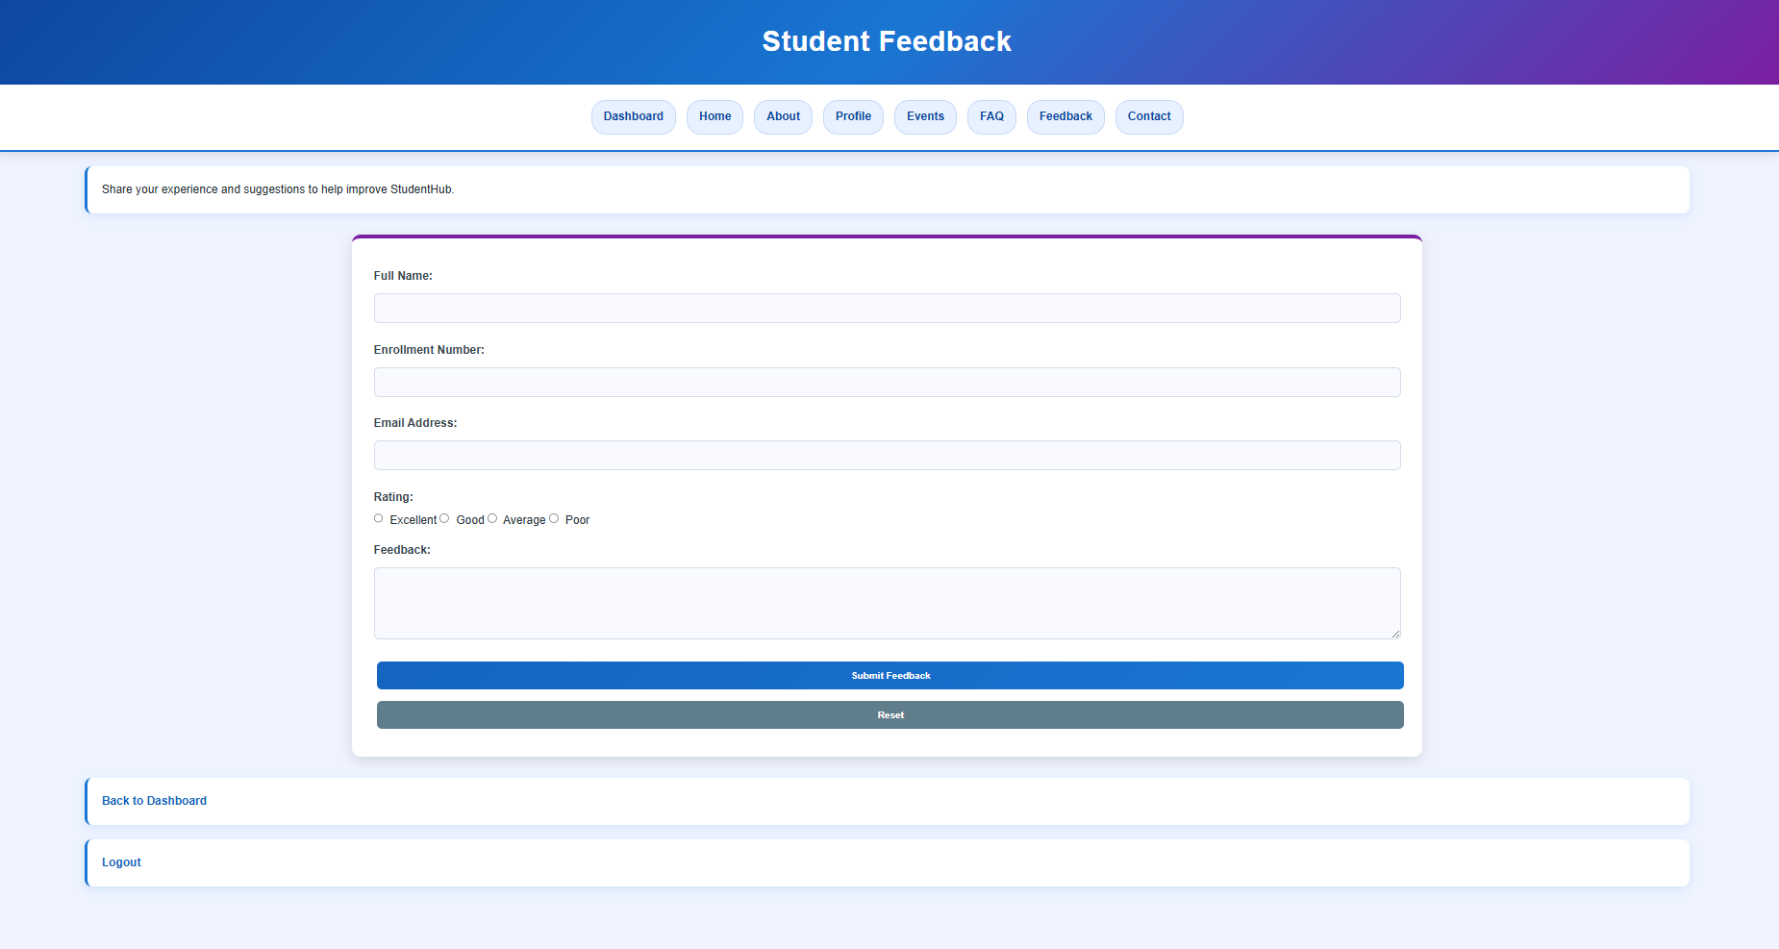

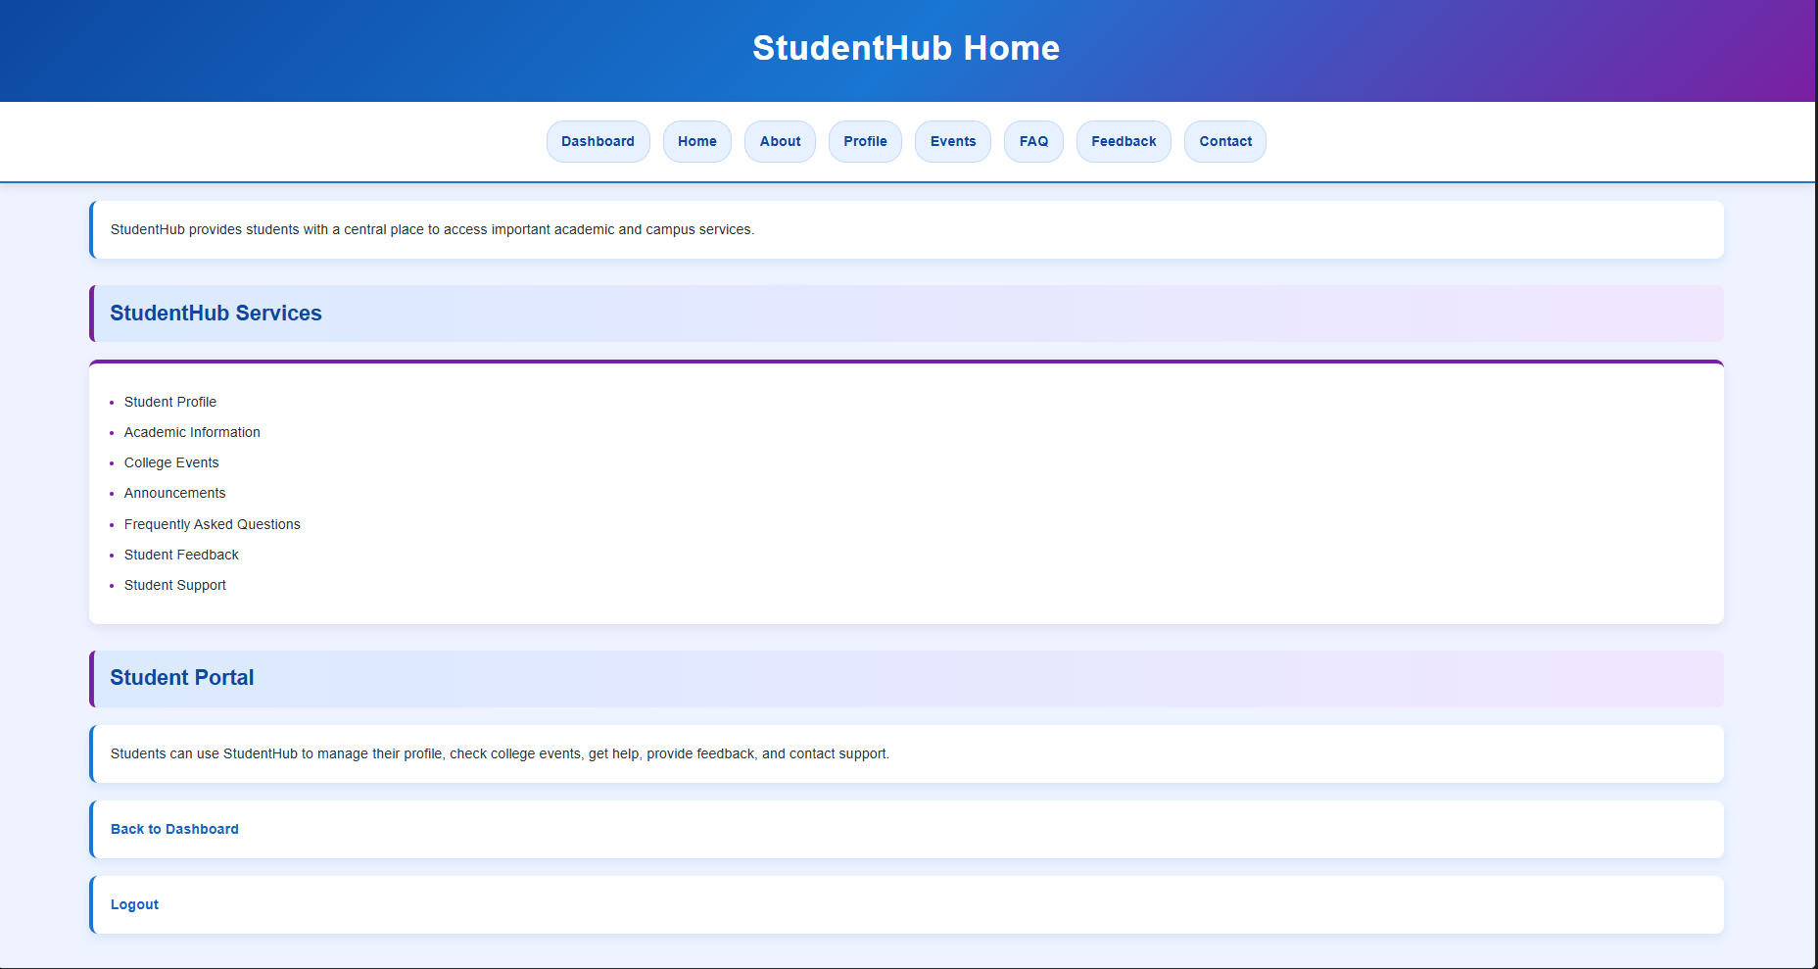

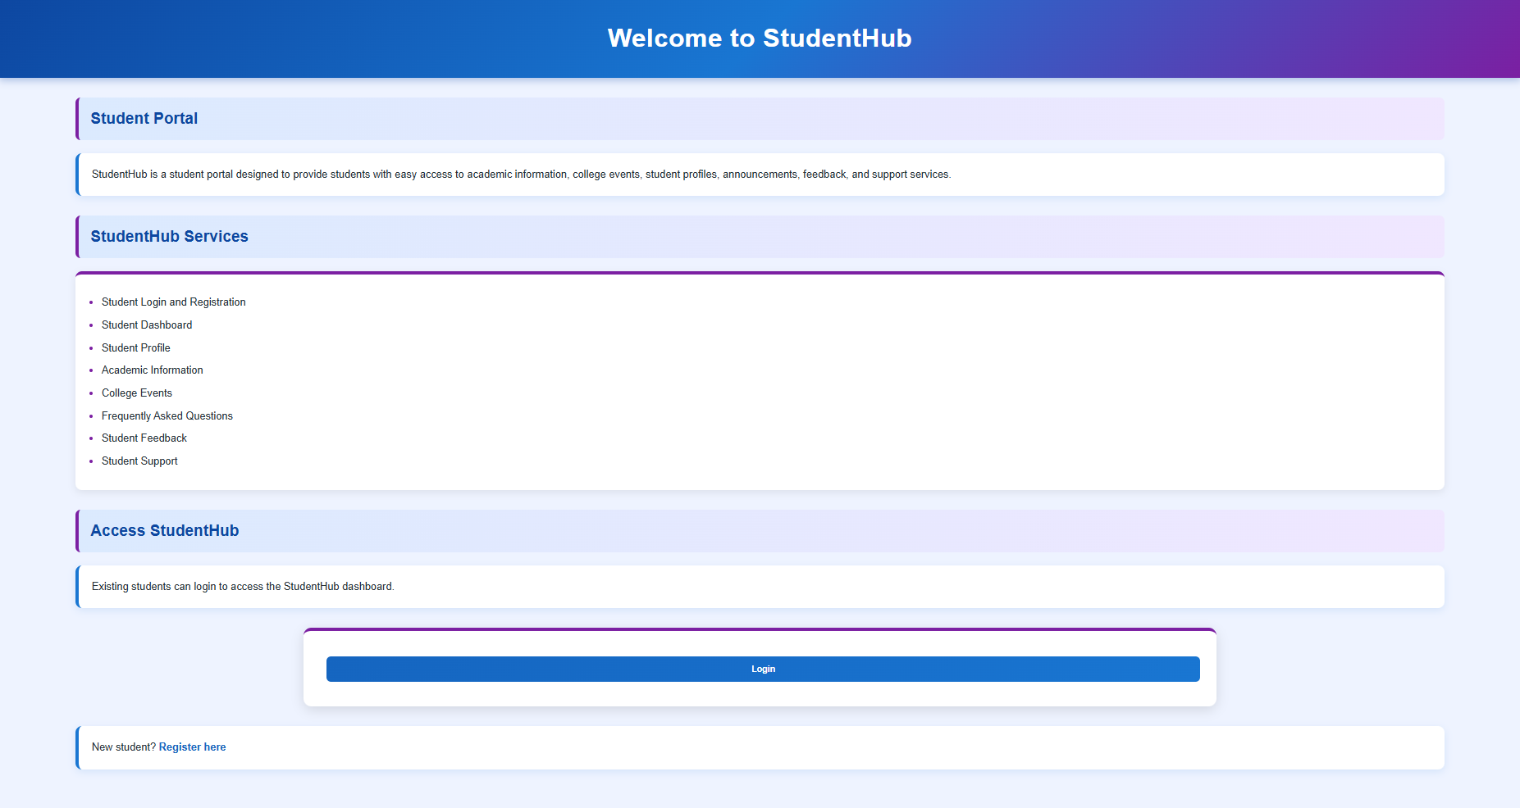

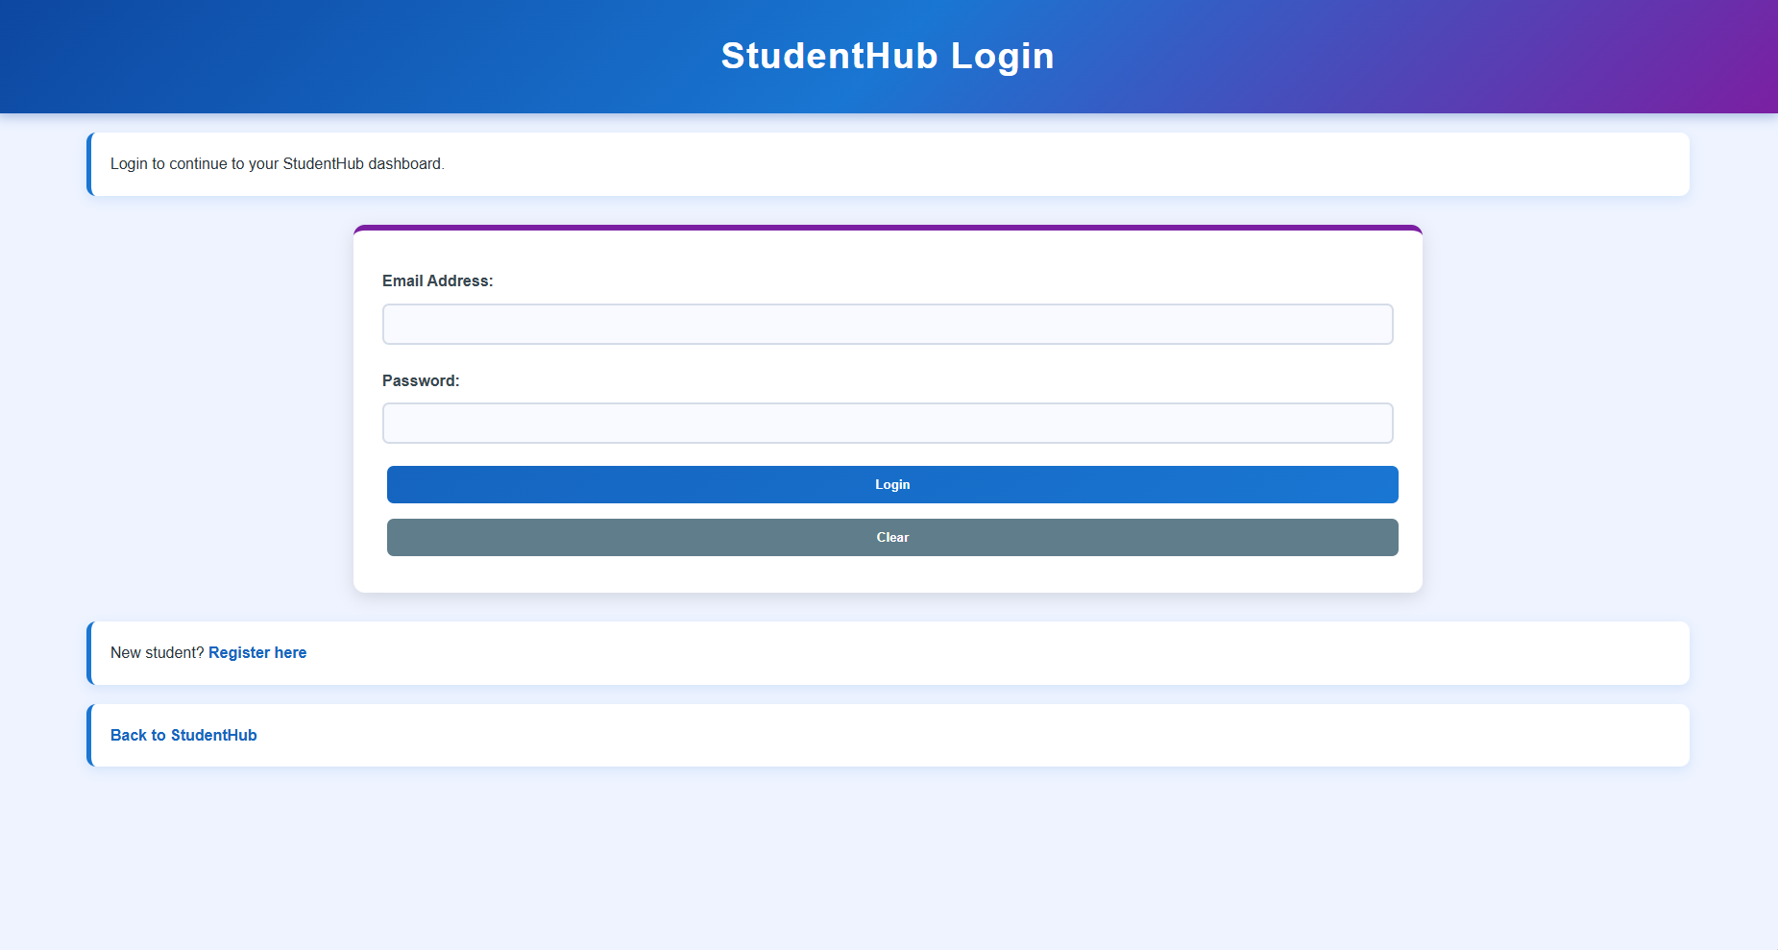

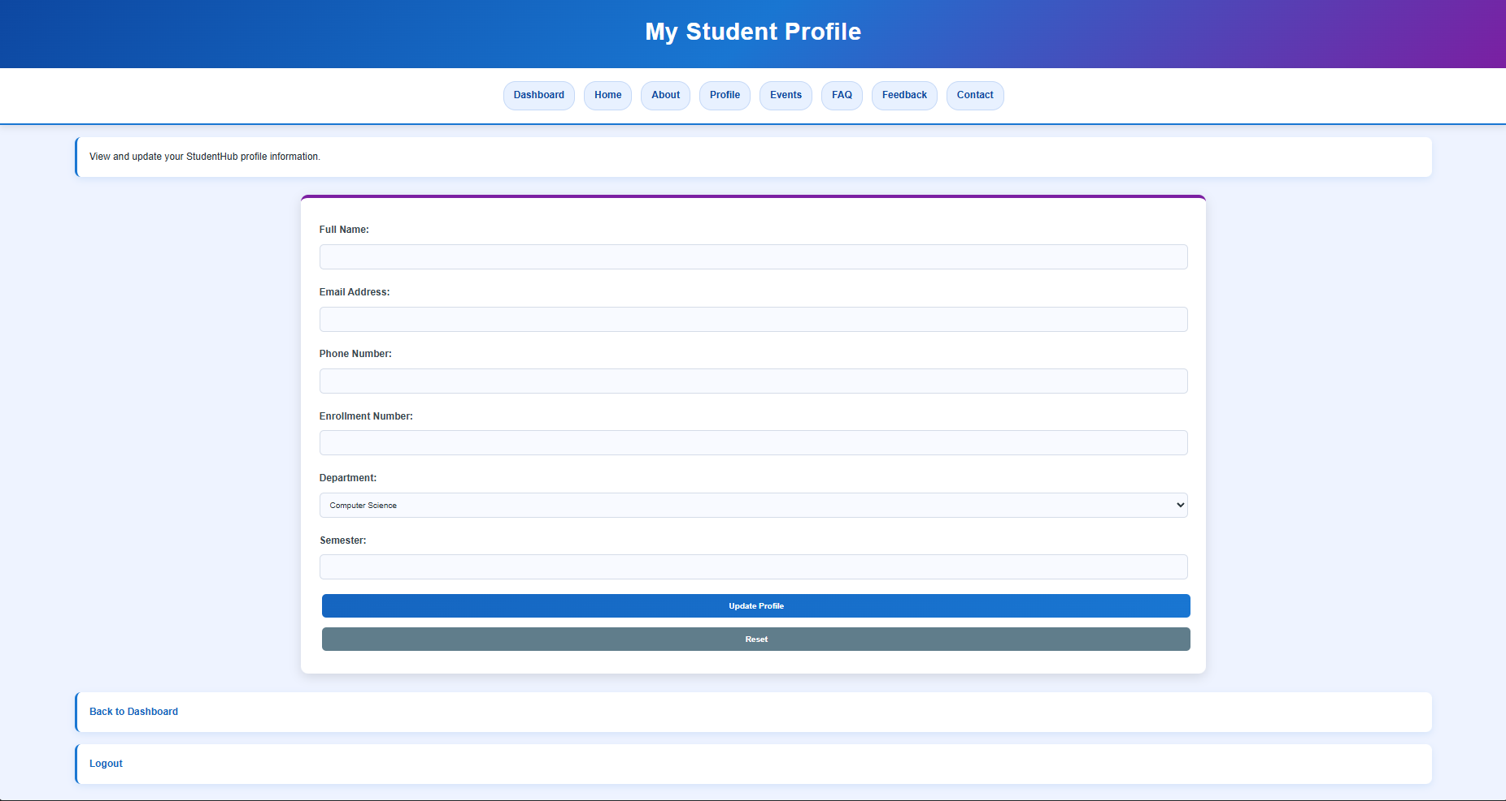

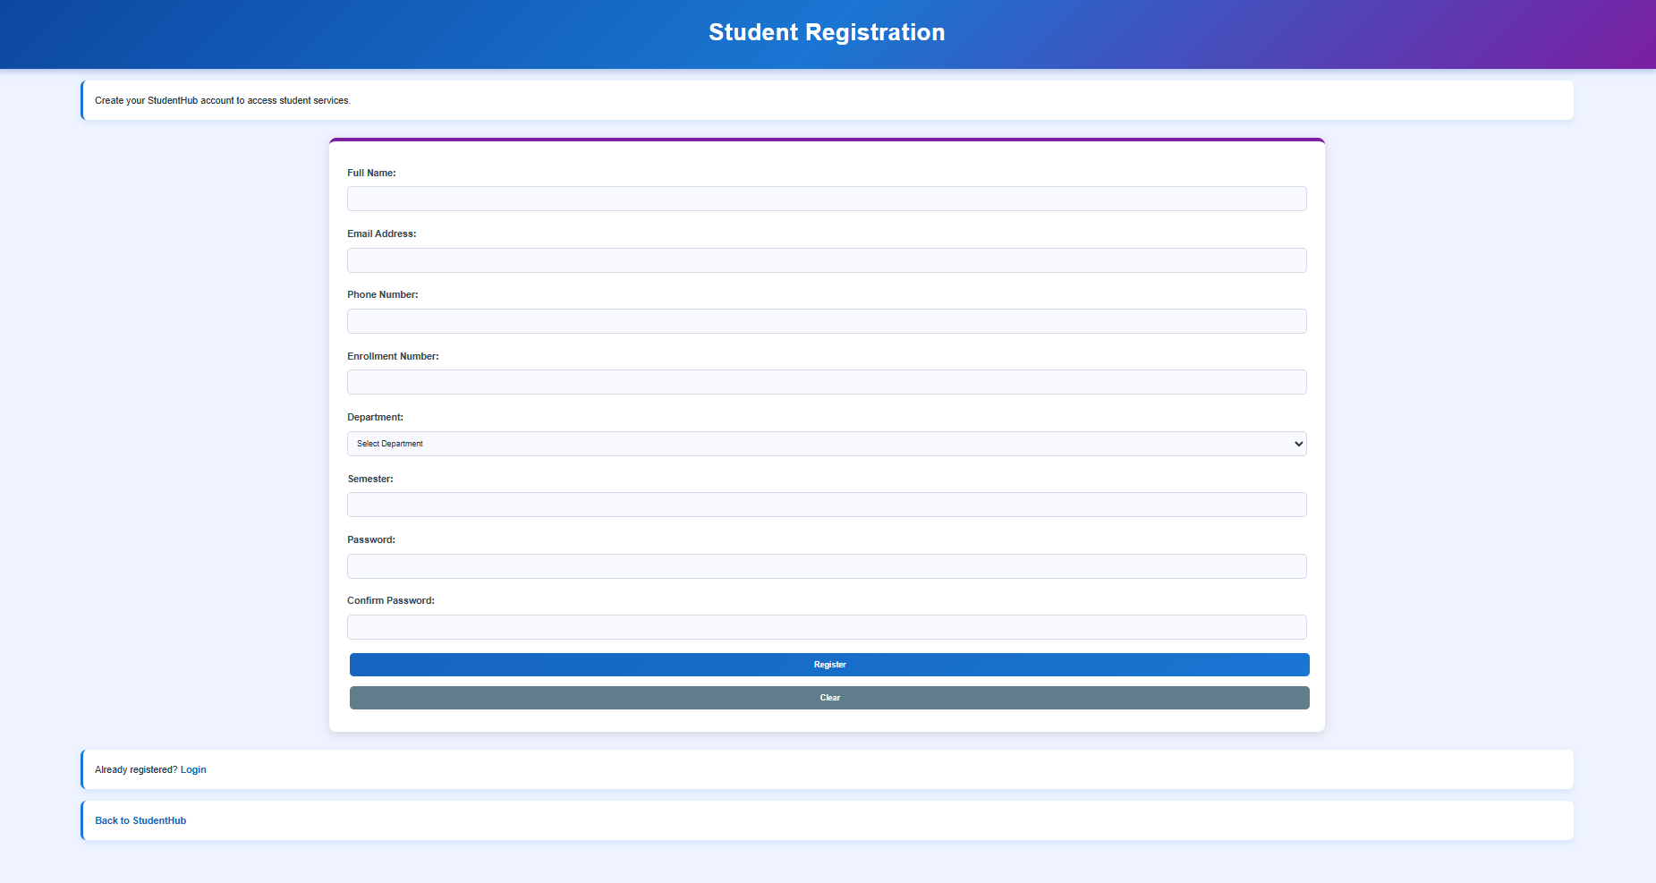

GitHub Repository Link:

https://github.com/rushiaghara25/StudentHub-Portal-2.git

Challenges Faced:
Faced difficulty in making the website responsive for different screen sizes.
Learned how to use CSS Flexbox and CSS Grid to align elements properly.
Fixed layout and spacing issues using media queries.
Ensured all pages displayed correctly on mobile, tablet, and desktop devices.

Learning Outcomes:
Learned the concepts of responsive web design.
Understood the use of CSS Flexbox and CSS Grid for layouts.
Gained experience in creating mobile-friendly web pages.
Learned to use Bootstrap/Tailwind classes for faster UI development.

Faculty Remarks: (Keep this blank for faculty)

Practical - 4
Practical Title: JavaScript DOM Manipulation, Event Handling, and UI Interactivity
Problem Definition: Add dynamic UI components such as collapsible FAQ, modal popup, image/content slider, notification banner, hamburger menu, and light/dark theme switcher using JavaScript.

Theory :
1. How are DOM elements selected and modified?

DOM manipulation means selecting an HTML element using JavaScript and then changing its text, HTML, style, attributes, classes, or values.

2. Are event listeners attached correctly?

Yes, event listeners are correctly attached using addEventListener(). It connects an HTML element with an event such as click or submit and executes a function when that event occurs.
3. Is localStorage used for remembering theme choice?

Yes. localStorage can be used to remember the user's theme choice. setItem() stores the selected theme, and getItem() retrieves it when the page is reopened, allowing the website to maintain the Dark/Light mode preference.
4. Does interactivity improve usability without breaking accessibility?

Yes. Interactivity improves usability when features such as buttons, notifications, menus, and forms make the website easier to use. Accessibility should be maintained by using proper HTML elements, keyboard support, readable text, clear messages, and sufficient contrast so all users can interact with the website.

Implementation/ Output/Result



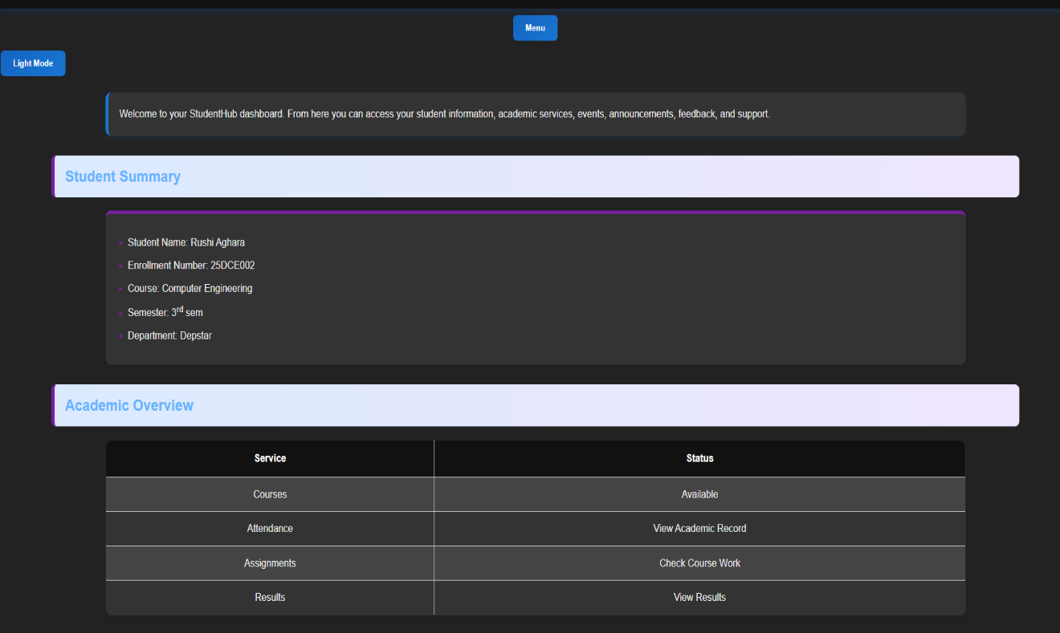

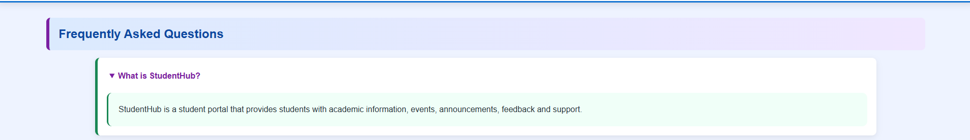

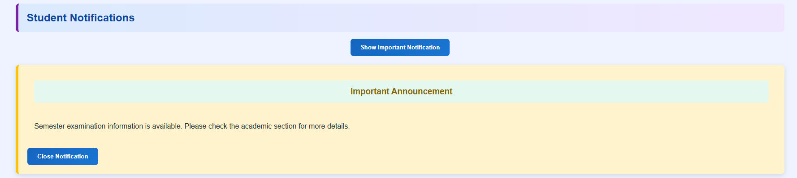

GitHub Repository Link:

https://github.com/rushiaghara25/StudentHub-Portal-2.git

Learning Outcomes:
- Use JavaScript DOM manipulation
- Handle user events like clicks and form submissions
- Create interactive UI components
- Implement dark/light theme switching
- Use localStorage to remember user preferences
- Improve the website's usability and interactivity.

Faculty Remarks: (Keep this blank for faculty)

Practical - 5
Practical Title: Registration Form with Frontend Validation and User-Friendly Error Handling
Problem Definition: Create a student registration form with HTML5 input types and JavaScript validation for name, email, mobile number, password, confirm password, course, year, gender, and terms acceptance. Use Regular Expression for validations.

Theory :
1. Are correct input types and attributes used?

Yes, correct input types and attributes are used. Text is used for names, email for email addresses, password for passwords, and the required attribute ensures that mandatory fields cannot be left empty.

2. Are validation errors displayed near the relevant fields?

No. Validation errors are currently displayed through alert messages rather than near the relevant input fields.

3. Is password strength checked?

Yes, password strength is checked using JavaScript validation with minimum length and character requirements.

4. Is the form accessible using keyboard and screen-reader-friendly labels?

Partially. Keyboard access is supported, but labels should be linked to their corresponding input fields using the for attribute for better screen-reader accessibility.

Validation:
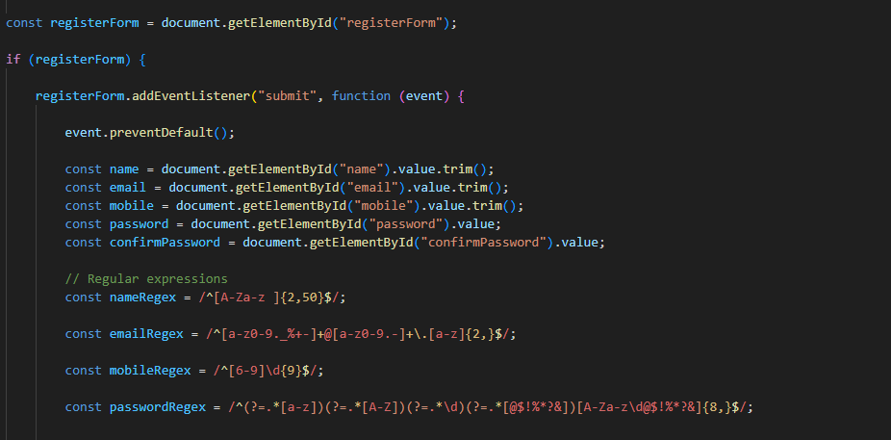

Implementation/ Output/Result
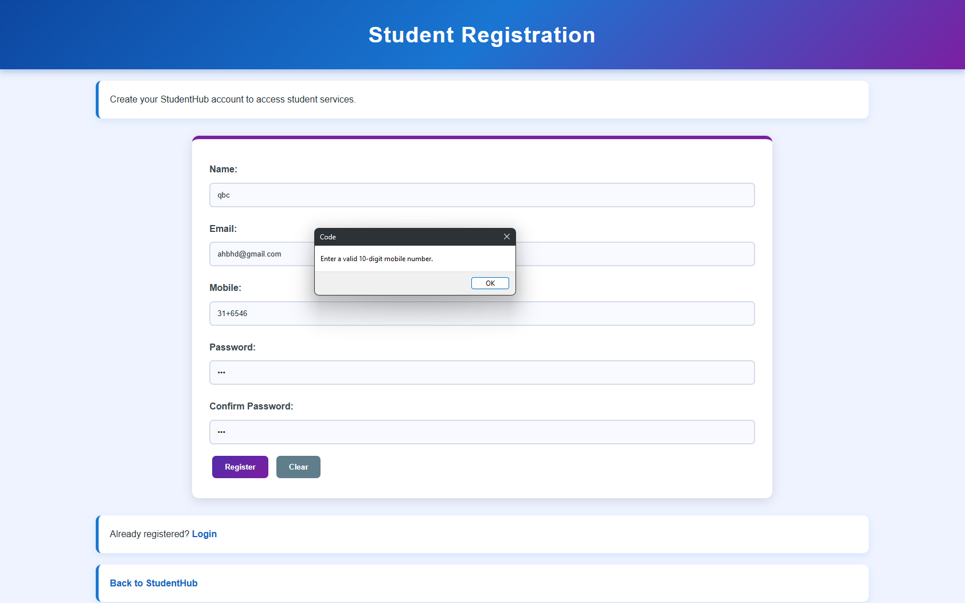

GitHub Repository Link:

https://github.com/rushiaghara25/StudentHub-Portal-2.git

Learning Outcomes:
- Understand HTML form creation and different input types.
- Implement client-side form validation using JavaScript.
- Use Regular Expressions for validating user inputs.
- Implement password strength and confirmation checks.
- Handle validation errors and provide user-friendly messages.
- Understand basic form accessibility for keyboard and screen-reader users.

Faculty Remarks: (Keep this blank for faculty)

Practical - 6
Practical Title: Rendering External JSON Data using Fetch API, Search and Filter
Problem Definition: Display event lists, student profiles, notices, or FAQs from external JSON files using Fetch API. Implement dynamic rendering, search, filter, sorting, and pagination.

Theory :
1. How is JSON fetched, parsed, and rendered?

JSON is fetched using the Fetch API, parsed using response.json(), and then rendered dynamically on the webpage using JavaScript DOM methods such as textContent or innerHTML.

2. Which array methods are used for search, filter, sort, and pagination?

filter() is used for search and filtering, sort() for sorting, and slice() for pagination.

3. How are loading and error states handled?

Loading is handled using the Fetch API, while errors are handled using the .catch() method and displayed in the browser console.

4. How is modularity maintained in JavaScript files?

Modularity is maintained by using an external JavaScript file and separating different functionalities into independent code sections or functions.

Data:
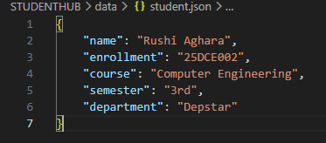
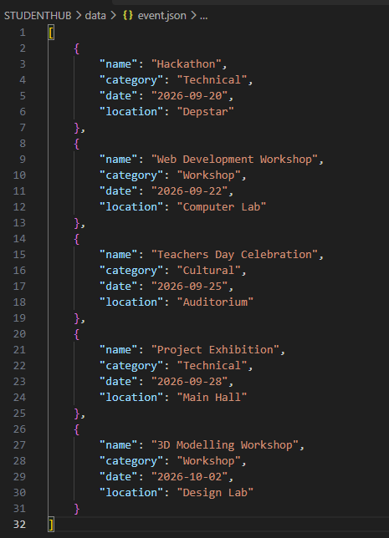

Implementation/ Output/Result
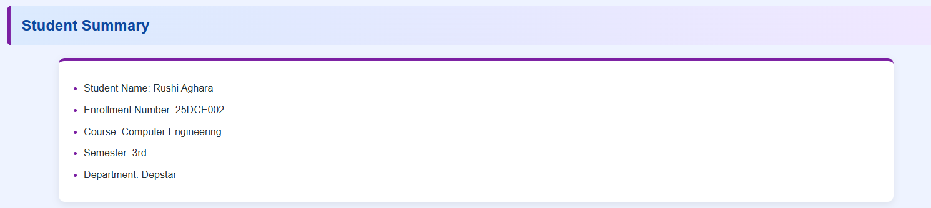
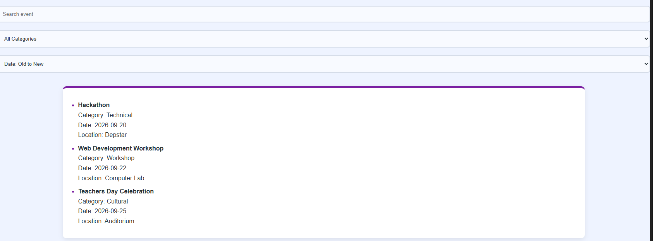

GitHub Repository Link:

https://github.com/rushiaghara25/StudentHub-Portal-2.git

Learning Outcomes:

Understand how to fetch and parse external JSON data using the Fetch API.

Dynamically render JSON data on web pages using JavaScript.

Implement search, filtering, sorting, and pagination using JavaScript array methods.

Handle loading and error states while fetching data.

Develop modular and reusable JavaScript code for dynamic web applications.

Faculty Remarks: (Keep this blank for faculty)

Practical - 7
Practical Title: PHP Form Processing with Server-Side Validation and CSV/JSON File Storage
Problem Definition: Process submitted registration/contact form data using PHP. Validate and sanitize inputs on the server side and store records in CSV or JSON file format. Display success/error messages.

Theory :
1. Is the form submitted using POST?

Yes, the form uses the POST method to securely send form data to the PHP server for processing.

2. Are inputs validated and sanitized server side?

Yes, user inputs are validated and sanitized on the server side using PHP before being stored.

3. Is file writing handled safely?

Yes, file writing is handled safely by opening the CSV file in append mode, writing data using fputcsv(), and closing the file after writing.

4. Are success and error responses displayed clearly?

Yes, clear success and error messages are displayed to inform the user about the result of the form submission.

Data:

Implementation/ Output/Result
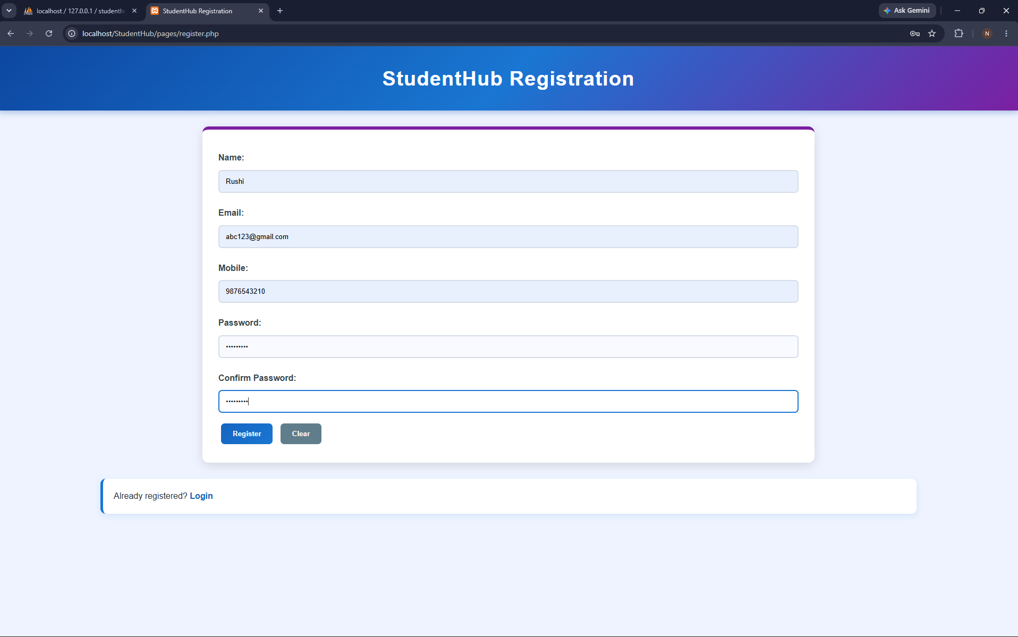
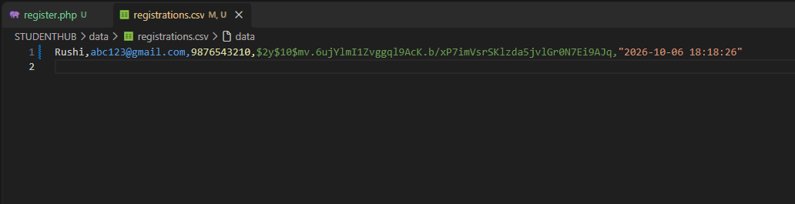

GitHub Repository Link:

https://github.com/rushiaghara25/StudentHub-Portal-2.git

Learning Outcomes:

Understand PHP form processing using the POST method.

Implement server-side validation and sanitization of user inputs.

Store form data safely in CSV or JSON files using PHP.

Handle file operations for storing submitted records.

Display clear success and error messages to users.

Develop basic backend form-processing skills using PHP and XAMPP.

Faculty Remarks: (Keep this blank for faculty)

Practical - 8
Practical Title: MySQL Schema Design, ER Model, PDO Connectivity, and Prepared Statements
Problem Definition: Design the database for StudentHub with students, events and registrations. Create PHP database connection using MYSQL statements.

Theory :
1. Is the schema normalized properly?

Yes. The StudentHub schema is properly normalized up to 3NF.

2. Are primary keys and foreign keys correctly defined?

Yes, the primary keys and foreign keys are correctly defined.

3. Is the database connection handled securely?

Yes, the database connection is handled securely for the project.

Data:

Implementation/ Output/Result

GitHub Repository Link:

https://github.com/rushiaghara25/StudentHub-Portal-2.git

Learning Outcomes:

Design a normalized MySQL database.

Create ER models with proper relationships.

Connect PHP to MySQL using PDO.

Use prepared statements for secure database operations.

Handle database errors securely.

Build secure database-backed web applications.

Faculty Remarks: (Keep this blank for faculty)

Practical - 9
Practical Title: Secure User Registration with Database Insert, Duplicate Email Check, and Password Hashing
Problem Definition: Implement secure user registration by inserting user details into MySQL using MYSQLi. Validate input on frontend and backend, check duplicate email/username, hash passwords using password_hash(), and display appropriate messages.

Theory :
1. Is password_hash() used before storing passwords?

Yes, your register.php uses password_hash($password, PASSWORD_DEFAULT) to hash passwords before storing them in MySQL. During login, password_verify() checks the password.

2. Is duplicate email/username checked?

Yes, your StudentHub project checks for duplicate emails using a UNIQUE constraint in MySQL and handles duplicate-entry errors in register.php by displaying an alert.

3. Are frontend and backend validations consistent?

Partially. Your register.php validates name, email, mobile number, password strength, and password confirmation on the backend. Frontend validation must use the same rules in script.js to be fully consistent.

Implementation/ Output/Result
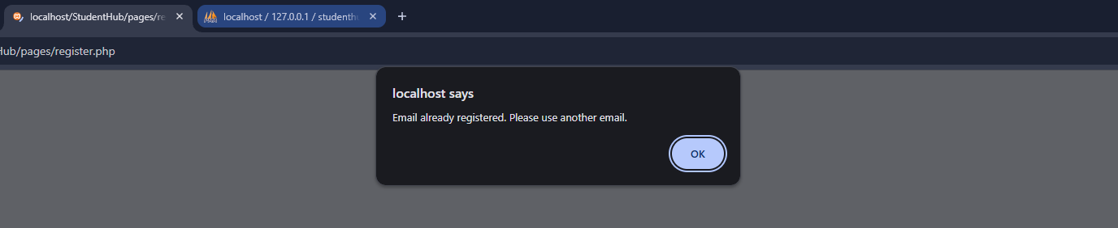
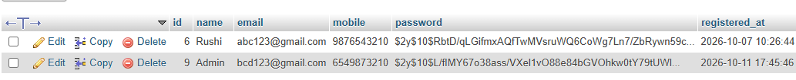

GitHub Repository Link:

https://github.com/rushiaghara25/StudentHub-Portal-2.git

Learning Outcomes:

Implemented secure user registration using PHP and MySQLi.

Applied frontend and backend input validation.

Checked duplicate email addresses.

Used password_hash() to store passwords securely.

Inserted user data into MySQL using prepared statements.

Displayed appropriate success and error messages.

Faculty Remarks: (Keep this blank for faculty)

Practical - 10
Practical Title: Secure Login/Logout with Sessions, Role-Based Access, Timeout, and Remember-Me Token
Problem Definition: Develop secure login and logout functionality using PHP sessions. Verify password using password_verify(), regenerate session ID after login, restrict dashboard access, implement role-based redirection, session timeout, and optional secure remember-me token.

Theory :
1. Are sessions started and destroyed securely?

Yes, your StudentHub project uses session_start() to start sessions, session_regenerate_id(true) after login, and session_unset() with session_destroy() during logout or session timeout to clear session data securely.

2. Is password_verify() used correctly?

Yes, your StudentHub login uses password_verify($password, $user["password"]) to compare the entered password with the hashed password stored in MySQL.

3. Is unauthorized dashboard access blocked?

Yes, unauthorized dashboard access is blocked if your dashboard.php checks $_SESSION["user_id"] and redirects users who are not logged in to login.php. Admin pages should also verify the user's role.

Implementation/ Output/Result
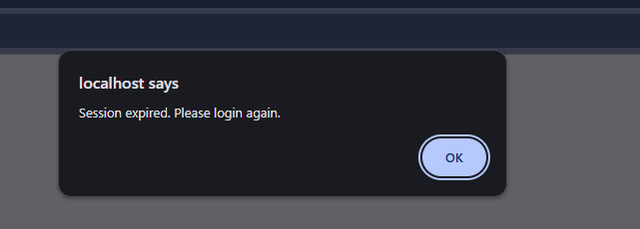

GitHub Repository Link:

https://github.com/rushiaghara25/StudentHub-Portal-2.git

Learning Outcomes:

Implemented secure login and logout using PHP sessions.

Verified passwords using password_verify().

Restricted dashboard access to authenticated users.

Implemented role-based access for students and administrators.

Added session timeout and secure session ID regeneration.

Improved authentication security and session management.

Faculty Remarks: (Keep this blank for faculty)

Practical - 11
Practical Title: Student Management CRUD with Search and Filter
Problem Definition: Create a student management module to add, view, edit, delete, search and filter student records. All database operations must use MySQLi statements and clear success/failure messages.

Theory :
- Are SELECT, INSERT, UPDATE, and DELETE operations working?
Yes. INSERT adds a new student record, SELECT displays all event records in a table, UPDATE edits the selected student record using an edit form, and DELETE removes a student record. All operations use MySQLi prepared statements, and a success or failure message is shown after each operation.

Is search by name/email/course implemented?
Yes. A search box sends the keyword using the GET method, and the SELECT query uses LIKE to match the name.

Are delete operations confirmed before execution?
No

Implementation/ Output/Result
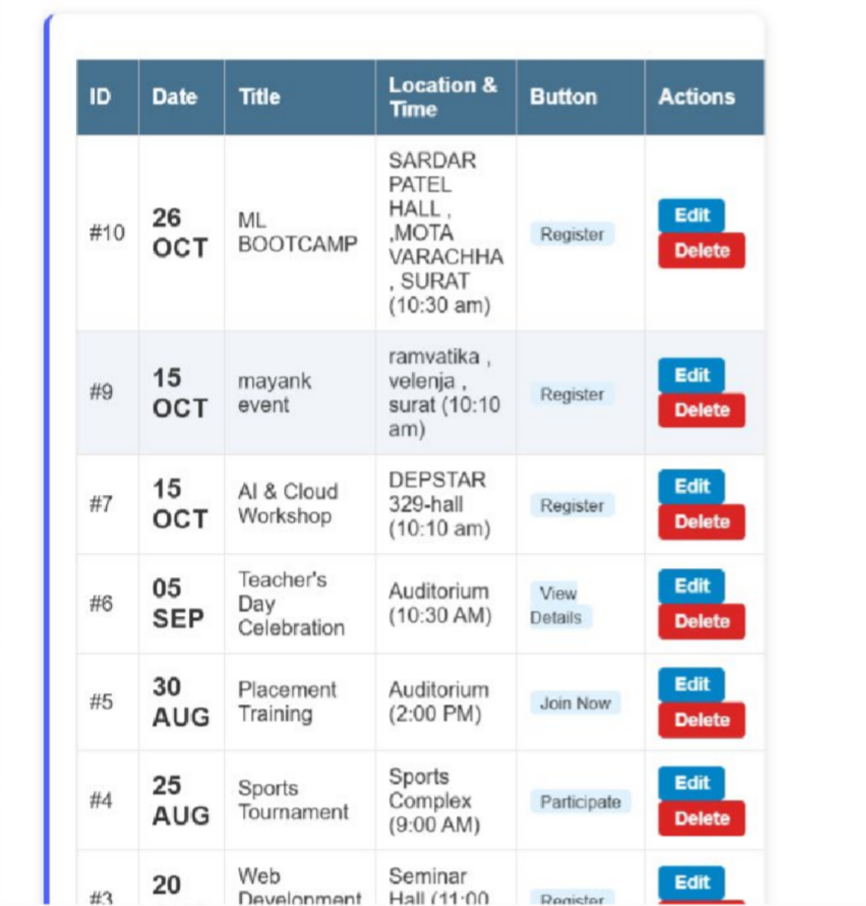

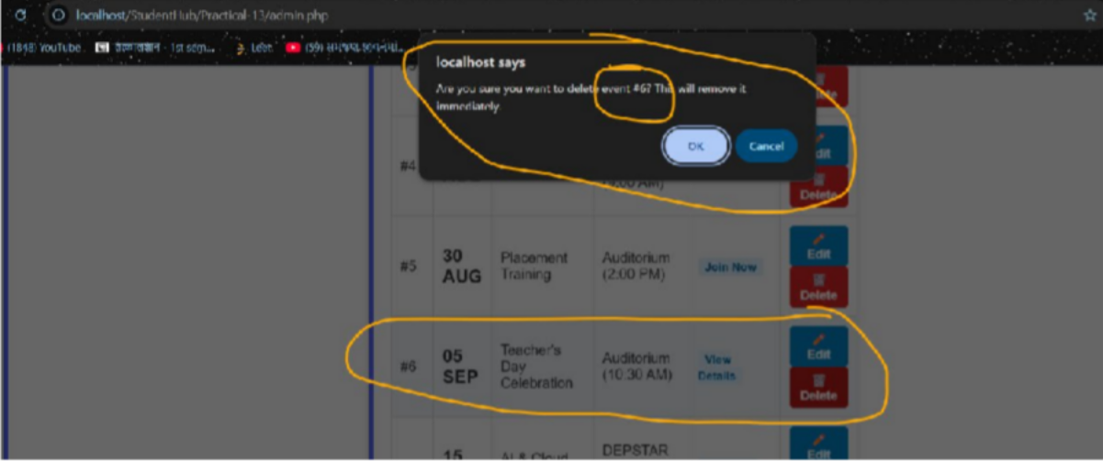

GitHub Repository Link:
https://github.com/rushiaghara25/StudentHub-Portal-2.git

Learning Outcomes:
- Understand how to perform CRUD operations using PHP and MySQLi.
- Implement search and filter for database records.
- Show clear success and failure messages to the user.
- Develop a complete and secure data-management page.

Faculty Remarks: (Keep this blank for faculty)

Practical - 12
Practical Title: Event Management CRUD with Poster Upload and File Validation
Problem Definition: Develop event management functionality for admin users. Admin can add, view, update, delete, and upload event posters with file type and file size validation.

Theory :
- Are add, update, and delete functionalities implemented correctly?
Yes. The admin can add a new event using a form, update an existing event by editing its saved details, and delete an event after confirmation. All queries use prepared statements, and these pages are available to admin users only.

Is the UI linked with the database correctly?
Yes. Events are fetched from the events table and shown in a table with Edit and Delete buttons. After any add, update or delete operation, the page shows the latest data from the database. Bootstrap is used to keep the page clean.

Are poster uploads validated for type and size? NO
- Are success and failure messages displayed?
NO

Implementation/ Output/Result
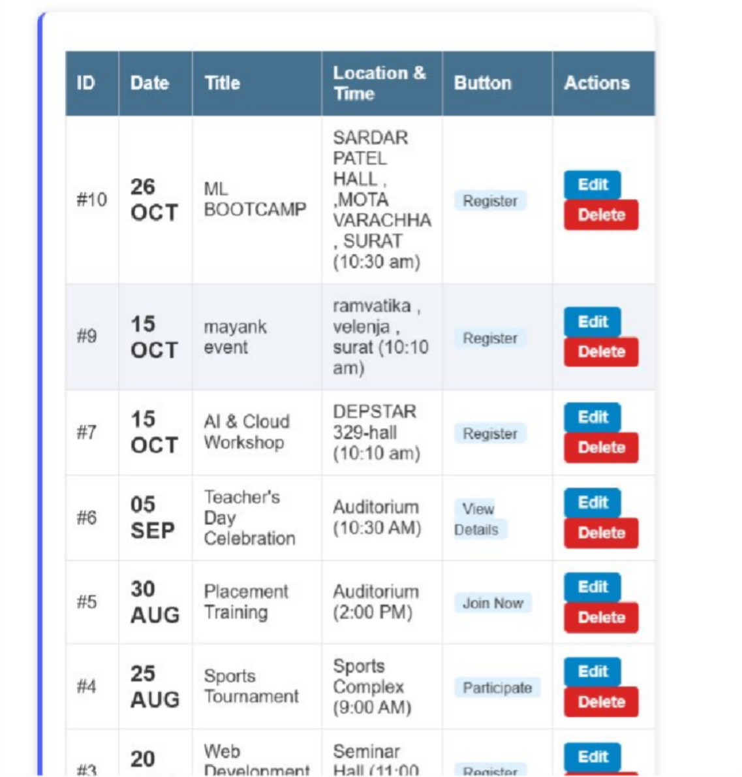
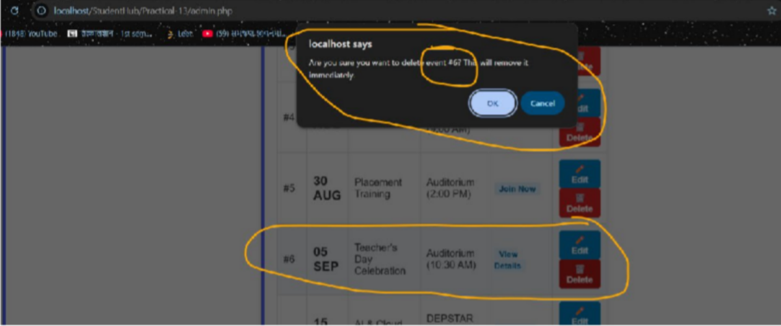

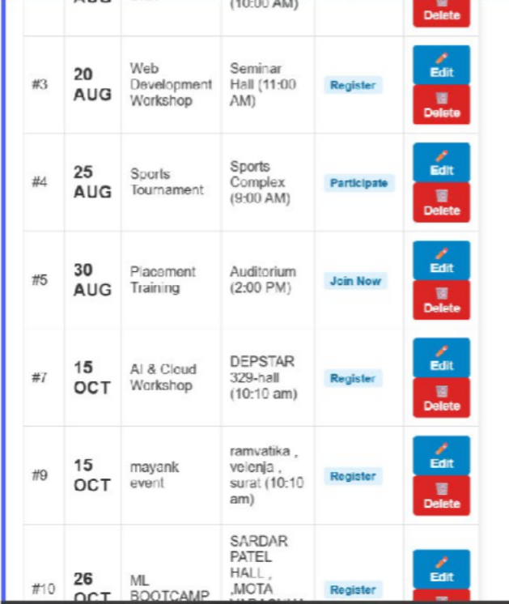
(#6 event deleted )
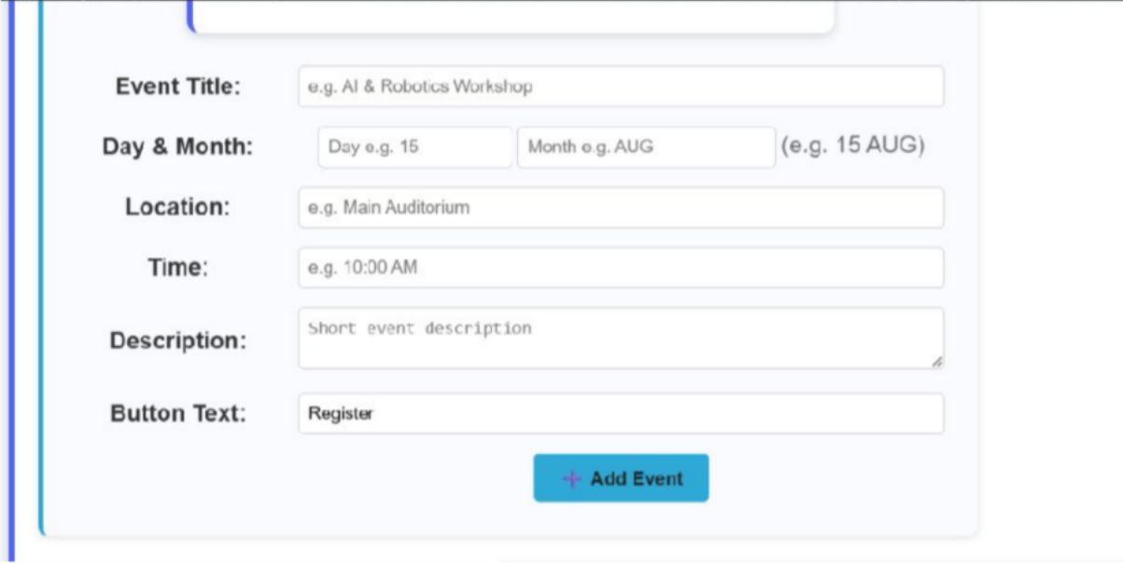

GitHub Repository Link:
https://github.com/rushiaghara25/StudentHub-Portal-2.git

Learning Outcomes:
- Implement a secure CRUD module for event management.
- Upload files in PHP with file type and file size validation.
- Restrict event management pages to admin users only.
- Link the user interface with the database and show proper messages.

Faculty Remarks: (Keep this blank for faculty)

Practical - 13
Practical Title: PHP JSON API and AJAX/Fetch-Based CRUD without Page Reload
Problem Definition: Create simple PHP JSON API endpoints for events or students and consume them using Fetch API. Perform list, add, update, and delete operations asynchronously without full page reload.

Theory :
- Do PHP endpoints return valid JSON responses?
Yes. Each endpoint sets the header Content-Type: application/json and returns the response using json_encode(). The response contains a status, a message and the data. The output can be checked in the Network tab of the browser.

Are GET and POST requests handled properly?
Yes. GET requests are used to list records, and POST requests are used to add, update and delete records. The endpoint checks $_SERVER['REQUEST_METHOD'], and for an unsupported method it returns an error response in JSON.

Are loading, success, and error states shown on the frontend?
Yes. A "Loading..." message is shown while the fetch request is running. After the response, the data is rendered and a success message is shown. If the response is not OK or the request fails, the error is handled using .catch() and an error message is displayed on the page.

Is input validation performed before database operations?
Yes. The PHP endpoint checks required fields, valid email format and numeric id, and trims the input before using it. Prepared statements are used for the queries, and for invalid input a JSON error message is returned instead of running the query.

Implementation/ Output/Result
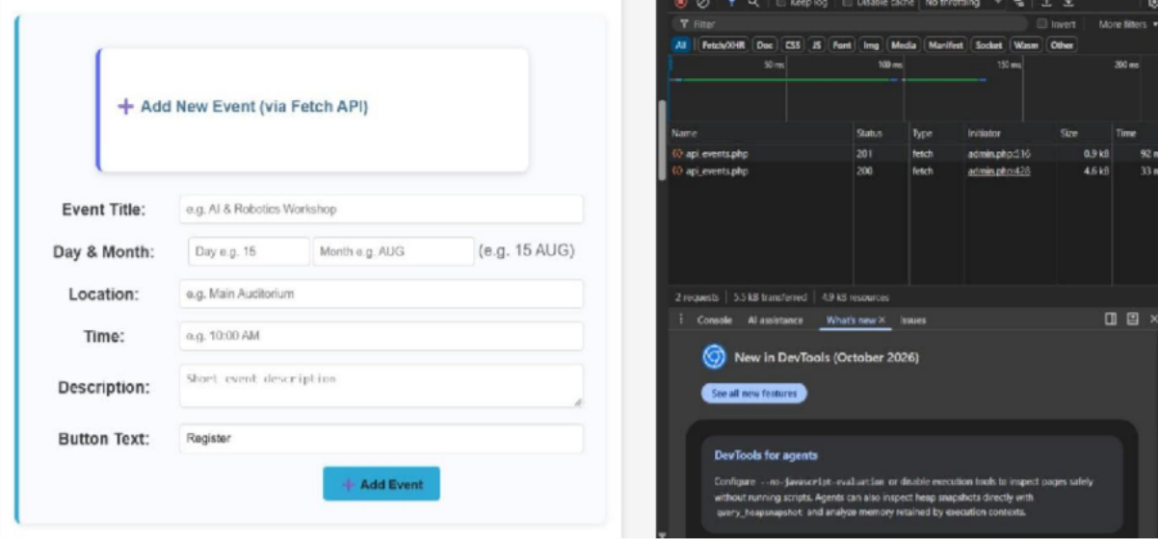

Event added without page reloading
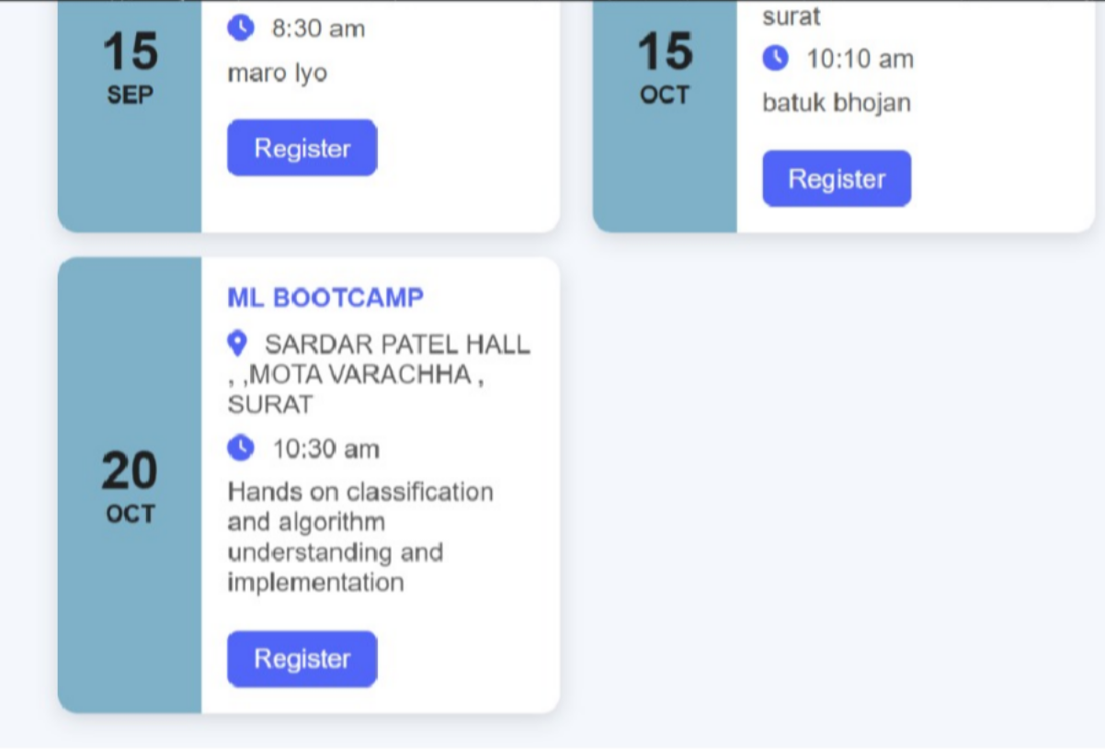

Added event named(ML BOOTCAMP)

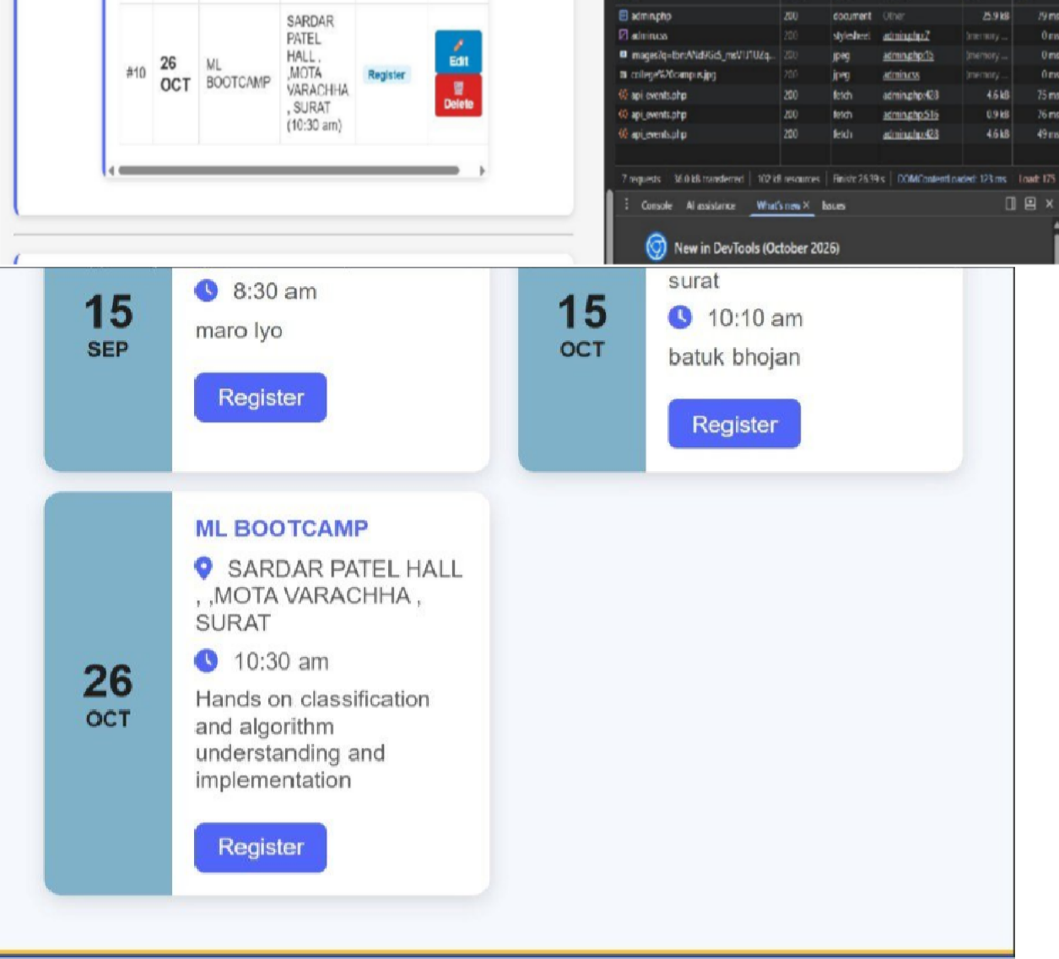

After editing date of ML BOOTCAMP event with 200 success status code
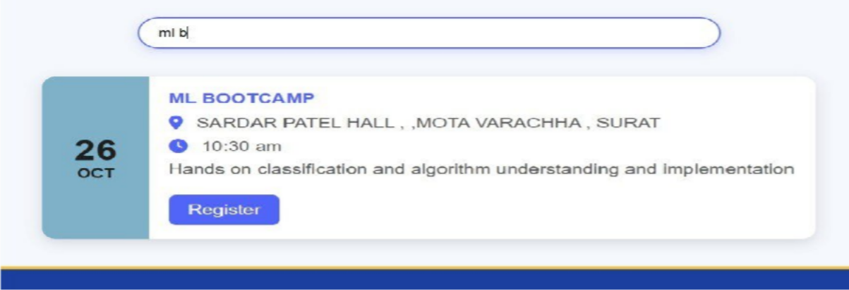
  - Search event in event page

GitHub Repository Link:
https://github.com/rushiaghara25/StudentHub-Portal-2.git
Learning Outcomes:
- Create PHP API endpoints that return JSON responses.
- Use the Fetch API to perform asynchronous CRUD operations.
- Handle GET and POST requests and validate input on the server.
- Show loading, success and error states on the frontend.
- Integrate frontend JavaScript with the PHP backend.

Faculty Remarks: (Keep this blank for faculty)

Practical - 14
Practical Title: Admin Dashboard with Role-Based Access Control, Dynamic Menu, and Audit Log
Problem Definition: Develop an admin dashboard that displays user statistics, student count, event count and latest registrations. Restrict access to admin users only and show dynamic menu options based on role.

Theory :
- Are dashboard values loaded dynamically from the database?
Yes. The user count, student count and event count are taken using SQL aggregation queries such as SELECT COUNT(*). The latest registrations are taken using a JOIN of the registrations, students and events tables with ORDER BY and LIMIT. No value is written manually in the code.

Is access restricted to admin users?
Yes. At the top of the dashboard page, the session is checked for a logged-in user and the role must be admin. If not, the user is redirected to the login page or shown an access denied message.

Are role-based menus working?
Yes. The menu is created in PHP according to the role saved in the session. Admin users see options such as Dashboard, Manage Students, Manage Events, Users and Audit Logs, while student users see only options such as Profile, Events and My Registrations.
- Are important admin actions recorded in audit_logs?
Yes. An audit_logs table stores the user id, action, details, IP address and date-time. A common function is called after important actions such as login, adding, editing or deleting students and events, and changing user status, so every action can be traced.

Implementation/ Output/Result
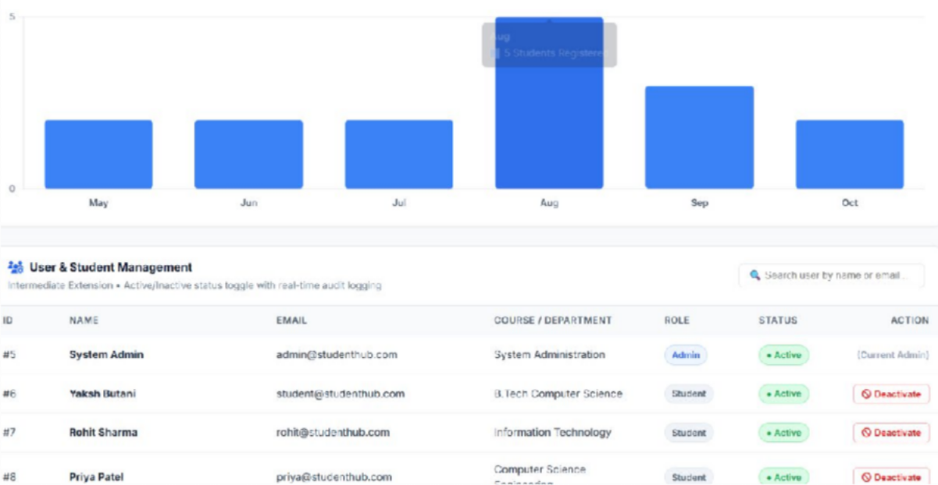

(Analysis)
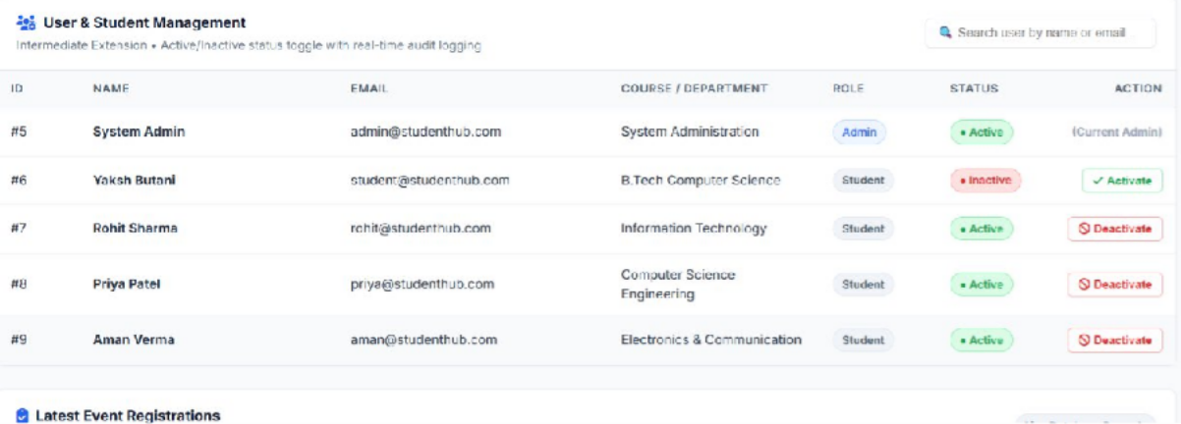

(After active to Deactive)

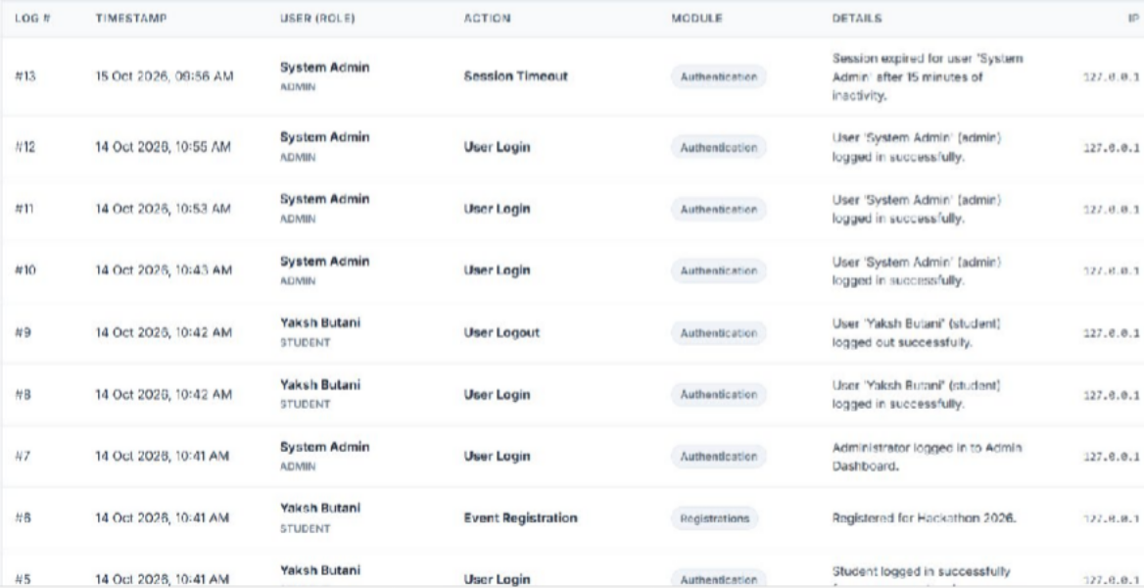

(Security Audit)
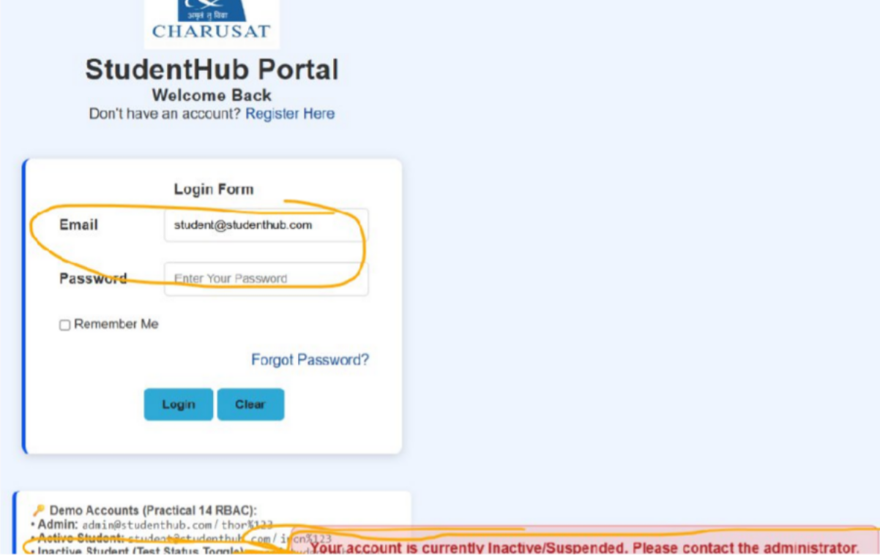

(Permission denied)
GitHub Repository Link:
https://github.com/rushiaghara25/StudentHub-Portal-2.git

Learning Outcomes:
- Build an admin dashboard with data loaded dynamically from MySQL.
- Implement role-based access control (RBAC) for pages.
- Create dynamic menus based on the user role.
- Record important admin actions using audit logs for traceability.

Faculty Remarks: (Keep this blank for faculty)

